

RESOURCE MANAGEMENT REGISTER
23IT454 - MINI PROJECT

A REPORT

Submitted by

K.SHREE HARINI (9517202306092)

S.SOWMIYA SHIVANI (9517202306096)
G.A.VARSHA (95172023060111)

MEPCO SCHLENK ENGINEERING COLLEGE, SIVAKASI (AUTONOMOUS)

APRIL 2025

BONAFIDE CERTIFICATE

Certified that this project report titled Resource Mangement Register the bonafide work of Ms.K.Shree Harini (9517202306092), Ms.S.Sowmiya Shivani (9517202306096) and Ms.G.A.Varsha (9517202306096) who carried out the research under my supervision. Certified further, that to the best of my knowledge the work reported herein does not form part of any other project report or dissertation on the basis of which a degree or award was conferred on an earlier occasion on this or any other candidate.

Ms.P.Rajalakshmi Dr.T.REVATHI, M.E., Ph.D.,
Internal guide Head of the Department
Assistant Professor, Senior Professor,
Department of Information Department of Information
Technology, Technology,
Mepco Schlenk Engineering College, Mepco Schlenk Engineering College,
Sivakasi. Sivakasi.

Submitted for Viva-Voce Examination held at MEPCO SCHLENK ENGINEERING COLLEGE, SIVAKASI (AUTONOMOUS) on …………………………

Internal Examiner I Internal Examiner II

ABSTRACT

ABSTRACT

This project focuses on the design and development of a resource management software application using Java for the frontend and a Database Management System (DBMS) for the backend. The software aims to streamline and optimize resource management by offering an intuitive user interface for interacting with resources and a robust backend for efficient data handling. Key features include resource allocation tracking, inventory management, role-based access control, and analytics for monitoring usage trends. The project emphasizes scalability, user-friendliness, and reliability, making it suitable for various organizational contexts where effective resource management is critical. By integrating these functionalities, the software provides a comprehensive solution to improve efficiency and decision-making in resource utilization.

TABLE OF CONTENTS

TABLE OF CONTENTS

CHAPTER  NUMBER | CONTENTS | PAGE NO
CHAPTER 1 | INTRODUCTION
1.1 | AIM | 8
1.2 | OBJECTIVE | 8
1.3 | PROBLEM DEFINITION | 9
1.4 | OBJECT ORIENTED PROGRAMMING CONCEPT | 9
1.5 | DATABASE MANAGEMENT CONCEPT | 12
1.6 | UNDERSTANDING OF THE PROBLEM | 15
CHAPTER 2 | SYSTEM DESIGN
2.1 | ER DIAGRAM | 24
2.2 | CLASS DIAGRAM | 26
CHAPTER 3 | IMPLEMENTATION METHODOLOGY
3.1 | MODULES IDENTIFIED | 27
3.2 | MODULE DESCRIPTION | 32
CHAPTER 4 | PROGRAM
 | JAVA | 39
 | DBMS | 80
CHAPTER 5 | RESULTS | 87
 | SCREENSHOTS | 89
CHAPTER 6 | CONCLUSION | 91
CHAPTER 7 | REFERENCES | 92
 | APPENDIX | 94

CHAPTER 1
INTRODUCTION

1.1 AIM:

The primary aim of this project is to develop an efficient and user-friendly resource management software that simplifies and enhances the process of organizing, allocating, and monitoring resources. By leveraging Java for a responsive frontend and a robust Database Management System (DBMS) for the backend, the software seeks to provide accurate tracking, effective utilization, and insightful analytics to optimize resource usage. This solution aims to cater to organizations or individuals requiring scalable and reliable tools for managing their resources seamlessly.

1.2 OBJECTIVES:
Streamline Resource Management: Develop a software system that simplifies tracking, allocation, and utilization of resources in real-time.
Enhance Usability: Create an intuitive user interface using Java, ensuring ease of navigation and accessibility for users of varying technical expertise.
Ensure Data Reliability: Design a secure and efficient backend using a Database Management System (DBMS) to store, retrieve, and manage resource data without compromising integrity.
Support Decision-Making: Integrate analytics and reporting tools to provide insights into resource usage trends, helping users make informed decisions.
Implement Role-Based Access: Enable controlled access through role-based permissions to maintain the security and confidentiality of sensitive data.
Promote Scalability: Build the system with scalability in mind to accommodate growing organizational demands and resource complexity.

1.3 PROBLEM DEFINITON
Effective resource management is critical for the smooth operation of the printing press industry, where a wide range of materials—such as calendars, flex, lamination sheets, and wedding invitations—are purchased from various customers. Currently, there is a need for a desktop application exclusively accessible to organizational employees that facilitates tracking stock counts, placing orders, and monitoring resource utilization for specific designs. Additionally, managers require enhanced functionalities, including employee data management, to oversee operations effectively. The absence of such a streamlined solution leads to inefficiencies in stock tracking, resource allocation, and operational decision-making. This project addresses these challenges by providing a robust software solution to optimize resource management and support the organization's growth and efficiency.

1.4 OBJECT ORIENTED PROGRAMMING CONCEPTS
Java is a strongly object-oriented programming language that relies on key OOP principles to structure its code effectively
1.4.1 Encapsulation
Encapsulation refers to bundling the data (variables) and methods (functions) operating on the data into a single unit, called a class. It helps safeguard the internal state of an object from external interference. Access modifiers like private, protected, and public are used to control access to class members.
EXAMPLE:
public class Resource {
private int stock;
public int getStock() {
return stock;
}
public void setStock(int stock) {
this.stock = stock;
}
}

1.4.2. Inheritance
Inheritance allows one class (child/subclass) to acquire the properties and methods of another class (parent/superclass). This promotes reusability and simplifies code maintenance
Example:
public class Employee {
String name;
}
public class Manager extends Employee {
int managerId;
}

1.4.3. Polymorphism
Polymorphism enables a single interface to support multiple methods or behaviors. It can take two forms: compile-time (method overloading) and runtime (method overriding).
Example
public class Resource {
public void count (int stock) {
System.out.println(stock);
}
public void count (String stockName) {
System.out.println(stockName);
}
}
1.4.4. Abstraction
Abstraction focuses on hiding implementation details and exposing only essential functionalities. Abstract classes and interfaces are used to achieve abstraction in Java
Example:
abstract class Order {
abstract void placeOrder();
}
class CustomerOrder extends Order {
void placeOrder() {
System.out.println("Order placed.");
}
}

1.4.5. Advantages of Using Java for Frontend Development
1.Platform Independence:
Java is renowned for its “Write Once, Run Anywhere” capability. Applications developed in Java can run on any platform with a Java Virtual Machine (JVM), eliminating platform-specific dependency issues.
2.Robust Libraries and Frameworks:
Java offers a rich collection of libraries and frameworks like JavaFX and Swing, which are essential for creating interactive and visually appealing graphical user interfaces (GUIs). These tools simplify frontend development, allowing developers to focus on functionality and user experience.
3.Security Features:
Java provides robust security features, including runtime checking, bytecode verification, and a built-in security API. This ensures frontend applications are safe from common vulnerabilities, an essential aspect when handling sensitive data.

4.Multithreading Support:
Java allows developers to build applications that can perform multiple tasks simultaneously using multithreading. This is especially beneficial for frontend applications that require responsive interfaces while executing background processes.
5. Extensive Community Support:
Java boasts a vast and active developer community, offering extensive resources, tutorials, and forums. This makes it easier to troubleshoot and find solutions during development.
6.Object-Oriented Paradigm:
Java follows the Object-Oriented Programming paradigm, allowing developers to create reusable and modular code, which aids in maintaining and scaling the software effectively.

1.5. Basic Concepts of Database Management System (DBMS)
1.5.1. Introduction to DBMS
A Database Management System (DBMS) is software designed to manage, organize, and retrieve data from databases efficiently. It acts as an intermediary between the user and the database, enabling seamless data manipulation while ensuring security, integrity, and consistency. Popular examples of DBMS include MySQL, Oracle, and Microsoft SQL Server.
1.5.2. Key Features of DBMS
- Data Organization: Structures data systematically to reduce redundancy and enhance storage efficiency.
- Data Retrieval: Offers powerful querying capabilities using Structured Query Language (SQL), enabling quick and accurate data access.
- Data Integrity: Maintains consistency and correctness of data across operations.
- Concurrency Control: Allows multiple users to access and manipulate the database simultaneously without conflicts.
- Security: Ensures that only authorized users can access sensitive information.

1.5.3. Core Concepts
1. Data Models
A data model defines how data is organized, stored, and manipulated within the database. Common models include:
- Hierarchical Model: Organizes data in a tree-like structure.
- Relational Model: Represents data as tables (relations) with rows and columns. This is the most widely used model and the foundation of MySQL.
- Network Model: Uses a graph structure to represent relationships.
- Object-Oriented Model: Stores data as objects, compatible with modern programming paradigms.
2. Relational Database Concepts
- Tables: Data is stored in rows (records) and columns (fields), forming a two-dimensional structure.
- Primary Key: A unique identifier for a record in a table, ensuring no duplicate rows exist.
- Foreign Key: Establishes relationships between tables by referencing the primary key of another table.
- Normalization: A process to minimize redundancy by organizing data into multiple related tables.
3. SQL (Structured Query Language)
SQL is the standard language for interacting with relational databases like MySQL. It is categorized into:
- DDL (Data Definition Language): Defines the structure of the database (e.g., CREATE, ALTER, DROP). Example:
sql
CREATE TABLE Resources (
ResourceID INT PRIMARY KEY,
ResourceName VARCHAR(50),
Quantity INT
);
- DML (Data Manipulation Language): Manages data within tables (e.g., INSERT, UPDATE, DELETE). Example:
sql
INSERT INTO Resources (ResourceID, ResourceName, Quantity)
VALUES (1, 'Paper', 100);
- DCL (Data Control Language): Handles permissions and access controls (e.g., GRANT, REVOKE).
• GRANT: This command is used to provide specific privileges to a user or role on the database objects. Example:
GRANT SELECT, INSERT ON Resources TO 'employee'@'localhost';
Explanation: This grants the SELECT and INSERT privileges to the user named employee for the table Resources.
REVOKE: This command removes previously granted privileges from a user or role. Example:
REVOKE INSERT ON Resources FROM 'employee'@'localhost';
Explanation: This revokes the INSERT privilege on the table Resources from the user named employee.
SHOW GRANTS: This command displays the privileges assigned to a specific user. Example:
sql
SHOW GRANTS FOR 'employee'@'localhost';
Explanation: This shows all the privileges granted to the user employee.
• SET PASSWORD: This command changes the password for a specific user. Example:
sql
SET PASSWORD FOR 'employee'@'localhost' = PASSWORD('new_password');
Explanation: This updates the password for the user employee to new_password.
4. Database Transactions
Transactions are operations performed on a database to maintain data integrity. Each transaction follows the ACID properties:
- Atomicity: Ensures all operations in a transaction are completed; otherwise, none are executed.
- Consistency: Ensures the database remains in a consistent state before and after the transaction.
- Isolation: Prevents transactions from interfering with one another when executed concurrently.
- Durability: Ensures data persists even in the case of system failure.
1.5.4. Advantages of Using MySQL for backend
- Open Source: MySQL is free to use and widely supported by the community.
- High Performance: Optimized for fast and efficient data handling, making it ideal for resource management systems.
- Scalability: Suitable for handling both small-scale applications and large, complex datasets.
- Cross-Platform Support: Runs seamlessly across various operating systems like Windows, Linux, and macOS.
- Ease of Use: User-friendly with a straightforward SQL syntax that is easy to learn and implement.

1.6. OUR UNDERSTANDING ON THE PROBLEM
The printing press industry operates in a dynamic environment where effective resource management is paramount to ensure smooth operations and meet customer demands. This industry deals with a diverse range of materials, including calendars, flex materials, lamination sheets, and wedding invitations, which are sourced from various customers. Each of these products requires careful tracking of stock levels, timely ordering of materials, and efficient utilization of resources to maintain production schedules and meet delivery deadlines.
Currently, the lack of a dedicated desktop application for organizational employees has resulted in significant inefficiencies. Employees often rely on manual processes or disparate systems to track stock counts, which can lead to errors, miscommunication, and delays in production. Without a centralized system, it becomes challenging to monitor resource utilization for specific designs, making it difficult to allocate materials effectively and optimize production workflows. This can result in overstocking or stockouts, both of which can negatively impact the organization’s bottom line and customer satisfaction.
Moreover, managers face additional challenges in overseeing operations due to the absence of enhanced functionalities for employee data management. Effective management requires access to real-time information about employee performance, resource allocation, and production metrics. Without a streamlined solution, managers may struggle to make informed decisions, leading to inefficiencies in operations and hindering the organization’s growth potential.
To address these challenges, the proposed project aims to develop a robust desktop application tailored specifically for the printing press industry. This application will serve as a centralized platform for employees to track stock counts, place orders, and monitor resource utilization for specific designs. By automating these processes, the application will reduce the likelihood of errors and improve overall efficiency in resource management.
The application will feature an intuitive user interface that allows employees to easily input and access stock information, place orders for materials, and track the status of resources in real-time. This will enable employees to make informed decisions regarding material usage and production schedules, ultimately leading to improved operational efficiency.
In addition to stock management, the application will include functionalities for employee data management, allowing managers to oversee employee performance, track attendance, and manage workloads effectively. This will provide managers with the insights needed to optimize team performance and ensure that resources are allocated appropriately.
Furthermore, the application will incorporate reporting and analytics features, enabling managers to generate reports on stock levels, resource utilization, and employee performance. This data-driven approach will facilitate better decision-making and strategic planning, allowing the organization to respond quickly to changing market demands and customer needs.
By implementing this software solution, the printing press industry can expect to see significant improvements in resource management, operational efficiency, and overall productivity. The streamlined processes will not only enhance the organization’s ability to meet customer demands but also support its growth and competitiveness in the market.
The code addresses the problem statement by providing a comprehensive solution for resource management in the printing press industry. Here’s how:
1.User Authentication: The application allows employees and managers to log in securely, ensuring that only authorized personnel can access sensitive information.
- Registration of New Users: The registration functionality allows new employees to create accounts, which helps in maintaining an updated database of users. This is essential for tracking who has access to the system and managing user roles effectively.
- Manager Workspace: The ManagerFrame class provides a dedicated workspace for managers to oversee operations. It includes buttons to manage employees, stock, and jobs, which streamlines the management process and enhances operational efficiency.
- Employee Management: The EmployeeManage class allows managers to add, edit, and delete employee records. This functionality is vital for keeping the employee database current and ensuring that the organization can quickly adapt to changes in staffing.
- Job Management: The JobsManage class enables managers to manage job records effectively. This includes adding new jobs, editing existing ones, and deleting jobs that are no longer relevant. This helps in maintaining an organized workflow and ensures that all job-related information is up to date.
- Stock Management: The StockManage class provides functionalities to manage stock records, including adding new stock items, editing existing records, and deleting items that are no longer in inventory. This is crucial for ensuring that the organization has the necessary materials on hand to meet customer demands.
- Viewing Stock: The ViewStockFrame class allows users to view low stock resources. This feature is essential for proactive inventory management, enabling the organization to reorder materials before they run out, thus preventing delays in production.
- Database Connectivity: The application connects to a MySQL database, which stores all relevant data, including user accounts, employee records, job details, and stock information. This centralized data management system ensures that all users have access to the most current information.
- Error Handling: Throughout the application, error handling is implemented to provide feedback to users in case of issues, such as invalid input or database connection failures. This enhances the user experience by guiding users to correct mistakes and ensuring smooth operation.
- User -Friendly Interface: The use of Java Swing for the graphical user interface (GUI) makes the application visually appealing and easy to navigate. This is important for user adoption, as a well-designed interface can significantly improve usability.
- Progress Feedback: The splash screen with a progress bar provides users with feedback during the loading process, enhancing the overall user experience by indicating that the application is starting up.

1.6.1. THE NEED FOR RESOURCE MANAGEMENT
The provided Java Swing application serves as a comprehensive resource management system tailored for the printing press industry, akin to a well-oiled machine where each cog plays a vital role in ensuring smooth operations. Imagine a bustling printing press, where every employee, from the manager to the production staff, relies on precise coordination and timely access to information. This application acts as the central nervous system of that machine, facilitating seamless communication and efficient management of resources, akin to a conductor leading an orchestra, ensuring that each musician plays in harmony.
At the forefront of this application is the Front Frame, which serves as the initial splash screen, much like the welcoming facade of a grand theater. As users enter, they are greeted by a visually appealing interface that builds anticipation through a progress bar, symbolizing the loading of essential resources and information. This initial interaction sets the tone for the user experience, creating an inviting atmosphere that encourages engagement.
Transitioning from the splash screen, users are directed to the Login Frame, where they must enter their credentials to access the system. This process is reminiscent of a security checkpoint at an airport, where only authorized personnel are allowed entry. The application validates user input against a database, ensuring that only those with the right credentials can proceed. For instance, a manager logging in might be greeted with a personalized welcome message, while an employee might see a different interface tailored to their specific needs. This differentiation is crucial, as it mirrors the distinct roles within a printing press, where managers oversee operations while employees focus on execution.
Once logged in, managers are ushered into the Manager Frame, a digital command center equipped with buttons that lead to various management functionalities. Here, they can oversee employee management, stock levels, and job assignments, much like a captain navigating a ship through turbulent waters. For example, if a manager notices a sudden spike in stock depletion, they can swiftly access the stock management section to investigate and address the issue before it escalates into a crisis. This proactive approach is vital in maintaining operational efficiency, akin to a skilled captain adjusting the sails to harness the wind effectively.
The Employee Management Frame allows managers to add, edit, or delete employee records, functioning like a human resources department in a corporate office. Imagine a scenario where a new employee joins the team; the manager can quickly input their details into the system, ensuring that they are integrated into the workflow without delay. Conversely, if an employee leaves, the manager can remove their information, maintaining an accurate and up-to-date roster. This fluidity in managing personnel reflects the dynamic nature of the printing industry, where staffing needs can change rapidly based on project demands.
Similarly, the Job Management Frame provides a platform for tracking job assignments and progress. This feature is akin to a project management tool, where tasks are assigned, deadlines are set, and progress is monitored. For instance, if a designer is working on a new wedding invitation, the manager can assign the job, set a deadline, and monitor its completion status. This level of oversight ensures that projects remain on schedule, much like a conductor ensuring that each section of the orchestra plays their part at the right time.
The Stock Management Frame is another critical component, allowing users to manage inventory levels of materials used in printing. Picture a warehouse filled with various supplies—paper, ink, and lamination sheets. The stock management system acts as an inventory tracker, alerting managers when supplies are running low, similar to a grocery store manager receiving alerts when popular items are about to run out. This functionality is crucial for maintaining production flow, as running out of essential materials can halt operations and lead to missed deadlines.
In the View Stock Frame, users can access a detailed overview of low stock resources, akin to a dashboard displaying vital statistics for a business. This feature empowers managers to make informed decisions about reordering supplies, ensuring that the printing press operates without interruptions. For example, if the system indicates that the stock of a particular type of paper is critically low, the manager can initiate an order immediately, preventing any potential delays in production.
The application’s database interaction is the backbone of its functionality, akin to the circulatory system in a living organism. It connects various components, ensuring that data flows seamlessly between the user interface and the underlying database. The use of MySQL as the database management system allows for efficient storage and retrieval of information, much like a well-organized filing cabinet that enables quick access to important documents. The application employs stored procedures to streamline complex queries, enhancing performance and ensuring that users receive timely information.
Moreover, the application incorporates robust error handling mechanisms, akin to safety nets in a circus act. If a user attempts to log in with incorrect credentials, the system provides immediate feedback, guiding them to rectify their mistakes. This user-centric approach fosters a positive experience, as users feel supported rather than frustrated by technical issues.
In conclusion, this Java Swing application exemplifies the intricate interplay of various components working together to create a cohesive resource management system for the printing press industry. Each frame serves a distinct purpose, contributing to the overall functionality and user experience
The Java Swing application is designed to help manage resources in a printing press, much like a well-organized factory where everything runs smoothly. Imagine a busy printing press where everyone, from the manager to the workers, needs to work together efficiently. This application acts like the brain of the factory, making sure everyone has the information they need to do their jobs well.
First, there is the Front Frame, which is like the welcome sign at the entrance of a store. It shows a splash screen with a progress bar, letting users know that the application is loading. This is similar to waiting for a movie to start, where you see previews before the main feature begins.
Next, users move to the Login Frame. This is like a security checkpoint at an airport. Users must enter their username and password to get in. For example, if a manager logs in, they might see a special welcome message, while an employee sees a different screen tailored for their tasks. This ensures that everyone gets the right information based on their role.
Once logged in, managers enter the Manager Frame, which is like a control room. Here, they can manage employees, stock, and jobs. For instance, if a manager sees that a certain type of paper is running low, they can quickly check the stock management section to reorder it. This is like a chef checking their pantry to make sure they have enough ingredients before cooking a meal.
The Employee Management Frame allows managers to add or remove employee records. Imagine a new worker joining the team; the manager can quickly enter their details into the system. If someone leaves, the manager can remove their information, keeping everything up to date. This is similar to updating a contact list on your phone when someone changes their number.
In the Job Management Frame, managers can track job assignments. For example, if a designer is working on a new wedding invitation, the manager can assign the job and set a deadline. This is like a teacher assigning homework to students and checking if they complete it on time.
The Stock Management Frame helps manage the inventory of materials used in printing. Picture a warehouse filled with paper, ink, and other supplies. The stock management system alerts managers when supplies are low, just like a grocery store manager gets notified when popular items are running out. For instance, if the system shows that the stock of a specific type of paper is low, the manager can order more right away.
In the View Stock Frame, users can see a list of low stock items. This is like a dashboard that shows important information. If the system indicates that a certain type of paper is critically low, the manager can quickly place an order to avoid running out. This is similar to a parent checking their pantry before planning dinner to ensure they have all the ingredients.
The application connects to a database, which is like a filing cabinet that stores all the important information. It uses MySQL to keep everything organized and easy to access. For example, when a manager wants to see how many employees are in the system, they can quickly pull up that information from the database.
The application also has error handling, which is like having a safety net. If a user tries to log in with the wrong password, the system will let them know right away, helping them fix the issue. This is similar to a teacher reminding a student to check their work before turning it in.
In summary, this Java Swing application is like a well-organized factory that helps manage resources in a printing press. Each part of the application has a specific job, making it easier for everyone to work together. For example, if a manager needs to check stock levels, they can do it quickly and efficiently. This application ensures that everything runs smoothly, just like a well-tuned machine.
1.6.2. Database Structure
The application relies on a well-structured database to store and manage data effectively. Here’s a breakdown of the key tables and their purposes:
- Users Table: Stores user information, including names, emails, phone numbers, usernames, and passwords. This table is crucial for authentication and user management.
- Supplier Table: Contains details about suppliers, including their names, contact information, and addresses. This information is essential for managing resources and ensuring that the organization can source materials effectively.
- Resources Table: Holds information about various resources used in the printing process, including resource names, types, quantities, and associated suppliers. This table is vital for inventory management.
- Employees Table: Manages employee records, including names, roles, and contact information. This table is important for tracking employee details and managing human resources.
- Machine Table: Contains information about the machines used in the printing process, including machine IDs, names, types, and statuses. This table helps in managing equipment and ensuring that operations run smoothly.
- Scoring Table: Records details about scoring jobs, including job IDs, scoring dates, and output quantities. This table is important for tracking job performance and resource utilization.
- Laminating Table: Manages records related to lamination jobs, including IDs, machine IDs, lamination dates, and output quantities. This table is essential for tracking the lamination process.
- Designing Table: Contains information about design jobs, including design IDs, software used, project names, creation dates, and design type IDs. This table is important for managing design projects.
- DesignType Table: Stores different types of designs, allowing for categorization and organization of design jobs.

1.6.3. Stored Procedures
The application utilizes stored procedures to encapsulate complex SQL queries and operations. For example, the GetLowStockResources() stored procedure retrieves resources that are low in stock, providing a streamlined way to access critical inventory information.

1.6.4. User Interface Design
The user interface is designed using Java Swing, which allows for the creation of a responsive and visually appealing application. Key design elements include:
- Panels: Different panels are used to organize components logically, such as header panels for titles and navigation buttons, and content panels for displaying tables and forms.
- Buttons: Action buttons are provided for user interactions, such as logging in, registering, and managing records. Icons are used to enhance the visual appeal and usability of buttons.
- Tables: JTable components are used to display data in a structured format, allowing users to view and manage records easily.

1.6.5. User Experience Considerations
- Feedback Mechanisms: The application provides feedback to users through dialog boxes, informing them of successful operations or errors. This is crucial for maintaining user engagement and trust in the application.
- Input Validation: Input fields are validated to ensure that users provide the correct data format, reducing the likelihood of errors and improving data integrity.
- Navigation: The application allows for easy navigation between different functionalities, such as employee management, job management, and stock management. This is important for enhancing user efficiency and satisfaction.
- Accessibility: The use of clear labels, tooltips, and intuitive layouts makes the application accessible to users with varying levels of technical expertises

1.6.6. JAVA DATABASE CONNECTIVITY
Java Database Connectivity (JDBC) is a Java-based API that enables Java applications to interact with various databases. It provides a standard interface for connecting to relational databases, executing SQL queries, and retrieving results. JDBC allows developers to perform operations such as creating, reading, updating, and deleting data in a database. The API consists of two main packages: java.sql and javax.sql, which provide classes and interfaces for database connectivity and data manipulation.
Additionally, JDBC supports transaction management, allowing for the execution of multiple SQL statements as a single unit of work, ensuring data integrity and consistency. Overall, JDBC is a crucial component for building robust and scalable Java applications that require database interaction.
1.6.7. ALERTING THE USER THROUGH MAIL
The resource management desktop application continuously monitors the inventory levels of various resources. When the resource count falls below a predefined threshold, the application triggers an alert mechanism to notify the user. This process begins by identifying the specific resource with low availability and obtaining the user's registered email address. The application then uses an email-sending library or API, such as JavaMail or an SMTP client, to compose an informative message detailing the low resource count and suggesting necessary actions. It connects securely to an SMTP email server with valid authentication credentials to send the email. The system also includes error handling to confirm that the email is successfully delivered or to manage any failures. This automated email alert helps users promptly replenish resources, preventing potential disruptions in operations. Additionally, all sent alerts are logged for tracking and future reference, ensuring efficient and accountable resource management
CHAPTER 2
SYSTEM DESIGN
2.1. ENTITY-RELATIONSHIP DIAGRAM

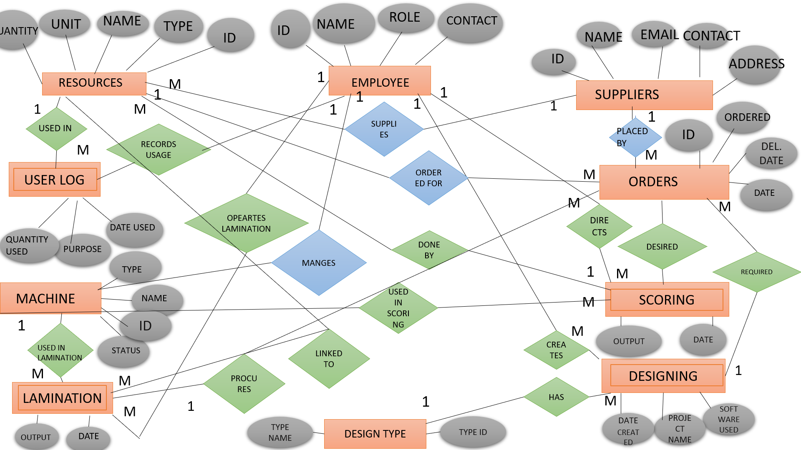

2.1.1. ENTITIES AND ATTRIBUTES
Resources(id,name,type,quantity,unit,supplier_id)
- Suppliers(supplier_id,name,contact,email,address)
- Employees(employee_id,name,role,contact)
- Usage log(resource_id,employee_id,date used.quantity used,purpose)
- Orders(orders_id,resource_id,supplier_id,order date,quantity ordered,expected delivery date)
- Machine(machine_id,name,type,status,employee_id)
- Scoring(order_id,employee_id,resource_id,machine_id,date,output quantity)
- Lamination (order_id,employee_id,resource_id,machine_id,date,output quantity)
- Designing(order_id,employee_id,resource_id,machine_id,date,output quantity)
- Design type(design_type id,type_name)
RELATIONSHIP | REDUNDANT ATTRIBUTE | INVOLVED ENTITES
Supplies | Supplier_id | Resource,supplier
Used in | Resource_id | Resorce,usagelog
Records_usage | Employee_id | Employee, usagelog
Order for | Resource_id | Resource, orders
Placed by | Supplier_id | Supplies, orders
manages | Employee_id | Employee, machine
Directs | Employee_id | Employee, scoring
Done by | Resource_id | Resource, scoring
Used in scoring | Machine_id | Machine, scoring
Operates lamination | Employee_id | Lamination, employee
Linked to | Resource_id | Lamination, resource
Used in lamination | Machine_id | Lamination,machine
Creates | Employee_id | Designing,desiging type
has | Design_type id | Designing,design type
desired | Order_id | Lamination,orders
procures | Order_id | Lamination,orders
required | Order_id | Designing,orders

2.2.CLASS DIAGRAM
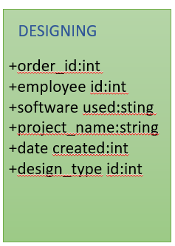
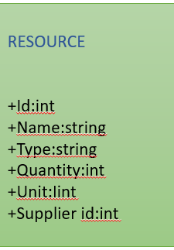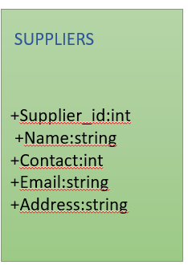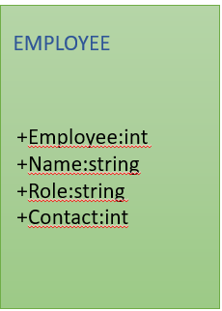
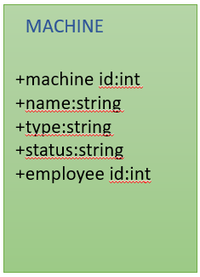
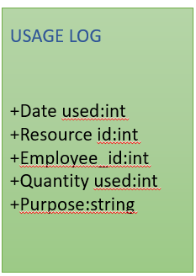
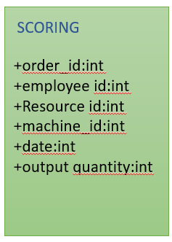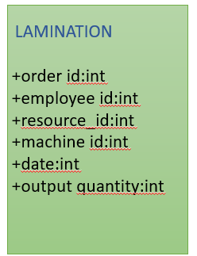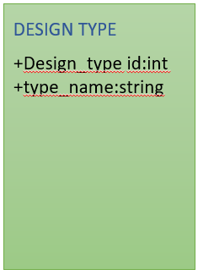

CHAPTER 3
IMPLEMENTATION METHODOLOGY
3.1. MODULES IDENTIFIED
3.1.1. Frontframe Class
- Purpose: Acts as the splash screen for the application.
Methods:
- Frontframe(): Constructor that initializes the components and starts the progress bar.
- startProgressBar(): Initializes and updates the progress bar, transitioning to the login screen once loading is complete.
- initComponents(): Sets up the user interface components for the splash screen.

3.1.2. LoginFrame Class
- Purpose: Handles user authentication.
Methods:
- LoginFrame(): Constructor that initializes the login frame and connects to the database.
- initComponents(): Sets up the user interface components, including labels, text fields, buttons, and checkboxes for showing/hiding passwords.
- LogbuttonActionPerformed(ActionEvent evt): Validates user input and calls the login() method to authenticate the user.
- User textActionPerformed(ActionEvent evt): Placeholder for handling actions on the username text field.
- ShowpasswordActionPerformed(ActionEvent evt): Toggles the visibility of the password field based on the checkbox state.

3.1.3. Registeration Class
- Purpose: Allows new users to register.
Methods:
- Registeration(): Constructor that initializes the registration frame.
- initComponents(): Sets up the registration form with fields for name, email, gender, phone number, username, and password.
- REgbuttonActionPerformed(ActionEvent evt): Validates input fields and calls the reg() method to add a new user to the database.

3.1.4. ManagerFrame Class
- Purpose: Provides a workspace for managers to oversee operations.
Methods:
- ManagerFrame(): Constructor that initializes the manager frame and displays a welcome message.
- initComponents(): Sets up the user interface with buttons for managing employees, stock, and jobs.
- LogoutActionPerformed(ActionEvent evt): Handles the logout action, closing the manager frame and returning to the login screen.

3.1.5. EmployeeManage Class
- Purpose: Manages employee records.
Methods:
- EmployeeManage(): Constructor that initializes the employee management frame.
- initComponents(): Sets up the interface for adding, editing, and deleting employee records.
- InsertbuttActionPerformed(ActionEvent evt): Inserts a new employee record into the database.
- EditbuttActionPerformed(ActionEvent evt): Updates existing employee records based on user input.
- DelbuttActionPerformed(ActionEvent evt): Deletes an employee record based on the provided employee ID.
3.1.6. JobsManage Class
- Purpose: Manages job records.
Methods:
- JobsManage(): Constructor that initializes the job management frame.
- initComponents(): Sets up the interface for managing job records.
- InsertbuttActionPerformed(ActionEvent evt): Inserts a new job record into the database.
- Del1buttActionPerformed(ActionEvent evt): Deletes a job record based on the provided job ID.
- Ed1buttActionPerformed(ActionEvent evt): Updates an existing job record.

3.1.7. StockManage Class
- Purpose: Manages stock records.
Methods:
- StockManage(): Constructor that initializes the stock management frame.
- initComponents(): Sets up the interface for managing stock records.
- InsertbuttActionPerformed(ActionEvent evt): Inserts a new stock record into the database.
- EditbuttActionPerformed(ActionEvent evt): Updates an existing stock record.
- DelbuttActionPerformed(ActionEvent evt): Deletes a stock record based on the provided product ID.

3.1.8. ViewStockFrame Class
- Purpose: Displays low stock resources.
Methods:
- ViewStockFrame(): Constructor that initializes the view stock frame.
- loadData(): Loads data from the database and populates the table with low stock resources.
- showButtonActionPerformed(ActionEvent evt): Calls the loadData() method to refresh the table with current data.

3.1.9. Database Connection Classes (loginform, registerform, Employee, Jobs, Stock)
These classes handle database connections and operations related to their respective functionalities.
Common Methods:
- connectToDatabase(): Establishes a connection to the MySQL database and handles exceptions related to database connectivity.
- getConnection(): Returns the current database connection.

3.1.10. loginform Class
- Purpose: Handles the database connection and login functionality.
Methods:
- connectToDatabase(): Establishes a connection to the MySQL database and handles exceptions related to database connectivity.
- login(): Authenticates the user by checking the provided username, password, and role against the records in the database.

3.1.11. registerform Class
- Purpose: Handles the database connection and registration functionality.
Methods:
- connectToDatabase(): Establishes a connection to the MySQL database and handles exceptions related to database connectivity.
- reg(): Inserts a new user record into the database after validating the input fields.
3.1.12. Employee Class
- Purpose: Manages employee-related database operations.
Methods:
- connectToDatabase(): Establishes a connection to the MySQL database and handles exceptions related to database connectivity.
- getConnection(): Returns the current database connection.

3.1.13. Jobs Class
- Purpose: Manages job-related database operations.
Methods:
- connectToDatabase(): Establishes a connection to the MySQL database and handles exceptions related to database connectivity.
- getConnection(): Returns the current database connection.

3.1.14. Stock Class
- Purpose: Manages stock-related database operations.
Methods:
- connectToDatabase(): Establishes a connection to the MySQL database and handles exceptions related to database connectivity.
- getConnection(): Returns the current database connection.
3.1.15. DisplayTables Class
- Purpose: Displays various tables from the database in a tabbed interface.
Methods:
- DisplayTables(): Constructor that initializes the display tables frame and connects to the database.
- connectToDatabase(): Establishes a connection to the MySQL database.
- createTablePanel(String sql): Creates a panel with a table based on the provided SQL query, populating it with data from the database.
- refreshAllTabs(): Refreshes the data displayed in all tabs by reloading the tables.

3.1.16. ViewStock Class
- Purpose: Displays low stock resources in a table format.
Methods:
- ViewStock(): Constructor that initializes the view stock frame and sets up the user interface.
- loadData(): Loads low stock resources from the database and populates the table with the current data.
- showButtonActionPerformed(ActionEvent evt): Calls the loadData() method to refresh the table with current data.

3.1.17. Stockmanager1 Class
- Purpose: Manages stock records specifically for employees.
Methods:
- Stockmanager1(): Constructor that initializes the stock management frame.
- initComponents(): Sets up the user interface for managing stock records.
- InsertbuttActionPerformed(ActionEvent evt): Inserts a new stock record into the database.
- EditbuttActionPerformed(ActionEvent evt): Updates an existing stock record based on user input.
- DelbuttActionPerformed(ActionEvent evt): Deletes a stock record based on the provided product ID.
- showStock(): Displays the current stock records in the table.

3.2. MODULE DESCRIPTION

3.2.1. Frontframe Class
- When the application starts, an instance of the Frontframe class is created, which displays a splash screen with a welcome message and a progress bar.
- The initComponents() method is called to set up the user interface components, including the progress bar and any labels or images.
- The startProgressBar() method initializes the progress bar's value to 0 and uses a Timer to increment the progress value. As the progress bar fills up, it simulates the loading process.
- Once the progress reaches 100%, the splash screen is disposed of, and the login frame (LoginFrame) is opened, allowing users to log in to the application.

3.2.2. LoginFrame Class
- The LoginFrame class initializes the login interface, which includes text fields for entering the username and password, as well as a button to submit the login request.
- The initComponents() method sets up the layout and components of the login form, including labels, text fields, and buttons.
- When the user clicks the login button, the LogbuttonActionPerformed() method is triggered. This method retrieves the input from the username and password fields and validates them.
- The login() method is called to check the provided credentials against the records stored in the database. It connects to the database, executes a query to find a matching username and password, and checks the user's role.
- If the credentials are valid, the user is granted access to the application, and the appropriate manager or employee interface is opened. If not, an error message is displayed to inform the user of the failed login attempt.

3.2.3. Registeration Class
- The Registeration class initializes the registration form, which includes fields for entering user details such as name, email, gender, phone number, username, and password.
- The initComponents() method sets up the layout and components of the registration form, ensuring that all necessary fields are present for user input.
- When the user clicks the register button, the REgbuttonActionPerformed() method is called. This method retrieves the input from the registration fields and performs validation to ensure all required fields are filled out correctly.
- The reg() method is then called to insert the new user record into the database. It connects to the database, prepares an SQL statement, and executes it to add the new user.
- If the registration is successful, the user is informed, and they can then log in using their new credentials.

3.2.4. ManagerFrame Class
- The ManagerFrame class initializes the manager's workspace, which includes buttons for managing employees, stock, and jobs.
- The initComponents() method sets up the user interface, arranging buttons and labels in a user-friendly layout.
- Each button is linked to an action listener that opens the corresponding management frame when clicked. For example, clicking the "Manage Employees" button opens the EmployeeManage frame, while the "Manage Stock" button opens the StockManage frame.
- This modular design allows managers to easily navigate between different management tasks without cluttering the interface.

3.2.5. EmployeeManage Class
- The EmployeeManage class initializes the employee management interface, which includes fields for entering employee details such as name, email, and role.
- The initComponents() method sets up the layout and components for managing employee records, including buttons for adding, editing, and deleting employees.
- When the user clicks the "Add Employee" button, the InsertbuttActionPerformed() method is triggered. This method retrieves the input from the fields and validates it before calling the database to insert the new employee record.
- The EditbuttActionPerformed() method allows managers to update existing employee records. It retrieves the selected employee's details, populates the fields, and updates the record in the database when the user submits the changes.
- The DelbuttActionPerformed() method enables managers to delete an employee record by providing the employee ID. It connects to the database, executes a delete query, and removes the specified record.

3.2.6. JobsManage Class
- The JobsManage class initializes the job management interface, which includes fields for entering job details such as job name, description, and status.
- The initComponents() method sets up the layout and components for managing job records, including buttons for adding, editing, and deleting jobs.
- When the user clicks the "Add Job" button, the InsertbuttActionPerformed() method is called. This method retrieves the job details from the input fields and validates them before inserting the new job record into the database.
- The Del1buttActionPerformed() method allows managers to delete a job record by providing the job ID. It connects to the database, executes a delete query, and removes the specified job record
- The Ed1buttActionPerformed() method allows managers to update existing job records. When the user selects a job from the list and clicks the edit button, this method retrieves the job's current details, populates the input fields with this information, and then updates the record in the database when the user submits the changes.
- The interface is designed to provide feedback to the user after each operation, such as confirming successful additions, updates, or deletions of job records.

3.2.7. StockManage Class
- The StockManage class initializes the stock management interface, which includes fields for entering stock details such as product name, quantity, and supplier information.
- The initComponents() method sets up the layout and components for managing stock records, including buttons for adding, editing, and deleting stock items.
- When the user clicks the "Add Stock" button, the InsertbuttActionPerformed() method is triggered.
- When the user clicks the "Add Stock" button, the InsertbuttActionPerformed() method is triggered. This method retrieves the stock details from the input fields, validates the input, and then calls the database to insert the new stock record.
- The EditbuttActionPerformed() method allows users to update existing stock records. When a stock item is selected and the edit button is clicked, this method retrieves the current details of the selected stock item, populates the input fields with this information, and updates the record in the database when the user submits the changes.
- The DelbuttActionPerformed() method enables users to delete a stock record by providing the product ID. It connects to the database, executes a delete query, and removes the specified stock record. After each operation, the interface provides feedback to the user, confirming the success or failure of the action.

3.2.8. ViewStockFrame Class
- The ViewStockFrame class initializes the interface for displaying low stock resources. This interface includes a table that shows items that are below a certain stock threshold.
- The loadData() method is responsible for retrieving low stock resources from the database. It executes a query to fetch items with quantities below the defined threshold and populates the table with this data.
- When the user clicks the button to refresh the stock view, the showButtonActionPerformed() method is called, which in turn calls the loadData() method to update the table with the most current low stock information.
- This class ensures that users can easily monitor stock levels and take necessary actions to reorder items that are running low.

3.2.9. Database Connection Classes (loginform, registerform, Employee, Jobs, Stock)
These classes handle the database connections and operations related to their respective functionalities.
Common Methods:
- connectToDatabase(): This method establishes a connection to the MySQL database. It uses JDBC (Java Database Connectivity) to connect to the database server, handling any exceptions that may occur during the connection process. If the connection is successful, it returns the connection object for further use.
- getConnection(): This method returns the current database connection object. It is used by other methods in the respective classes to perform database operations such as querying, inserting, updating, or deleting records.

3.2.10. loginform Class
- The loginform class is responsible for managing the login process. It connects to the database and checks user credentials.
- The connectToDatabase() method establishes a connection to the database, allowing the application to access user records.
- The login() method retrieves the username and password entered by the user, constructs a SQL query to check if the credentials match any records in the database, and verifies the user's role. If a match is found, the user is authenticated and granted access to the application.

3.2.11. registerform Class
- The registerform class manages the user registration process. It connects to the database to add new user records.
- The connectToDatabase() method establishes a connection to the database, enabling the application to insert new user data.
- The reg() method retrieves the user details from the registration form, constructs an SQL insert statement, and executes it to add the new user to the database. It also handles any validation to ensure that the input data is correct before attempting to insert it.

3.2.12. Employee Class
- The Employee class manages operations related to employee records in the database.
- The connectToDatabase() method establishes a connection to the database, allowing the application to perform operations on employee records.
- The getConnection() method returns the current database connection object, which is used by other methods to execute queries related to employee management.
3.2.13. Jobs Class
- The Jobs class manages operations related to job records in the database.
- The connectToDatabase() method establishes a connection to the database, enabling the application to perform operations on job records.
- The getConnection() method returns the current database connection object, which is used by other methods to execute queries related to job management.

3.2.14. Stock Class
- The Stock class manages operations related to stock records in the database.
- The connectToDatabase() method establishes a connection to the database, allowing the application to perform operations on stock records.
- The getConnection() method returns the current database connection object, which is used by other methods to execute queries related to stock management.

3.3. USAGE OF PROCEDURES
A procedure in DBMS is a set of SQL statement grouped together to perform a specifc task. It is a type of stored program in which you can define logic that is executed on database server .In our project we have used procedures to alert the employee about the reduction in stock count.
(i)Manager view
CREATE PROCEDURE GetLowStockResources()
BEGIN
SELECT r.rid, r.rname, r.rquantity, s.sname, s.contact,
CASE
WHEN r.rquantity <= 5 THEN 'Low Stock Warning'
ELSE ''
END AS error_message,
CASE
WHEN r.rquantity <= 5 THEN 'Order ASAP'
ELSE 'Sufficient'
END AS order_details
FROM resources r
JOIN supplier s ON r.sname = s.sname;
END$$
(ii) Employee resources
CREATE PROCEDURE GetLowStock()
BEGIN
SELECT r.rid, r.rname, r.rquantity, s.sname
CASE
WHEN r.rquantity <= 5 THEN 'Low Stock Warning'
ELSE ''
END AS error_message,
CASE
WHEN r.rquantity <= 5 THEN 'Order ASAP'
ELSE 'Sufficient'
END AS order_details
FROM resources r
JOIN supplier s ON r.sname = s.sname;
END$$
CHAPTER 4
PROGRAMS

4.1.JAVA CODE
LOGIN PAGE:
package miniproject;
import javax.swing.JOptionPane;
import java.sql.*;
public class LoginFrame extends javax.swing.JFrame {
loginform l=new loginform();
public LoginFrame() {
initComponents();
setLocationRelativeTo(null);
l.connectToDatabase();
setLocationRelativeTo(null);
}
private void RegisterActionPerformed(java.awt.event.ActionEvent evt) {
Registeration f=new Registeration();
f.show();
this.dispose();
}
private void ShowpasswordActionPerformed(java.awt.event.ActionEvent evt) {
if(Showpassword.isSelected()){
Passfield.setEchoChar((char) 0); //show password
}
else{
Passfield.setEchoChar('*');//Hide Password
}
}
private void LogbuttonActionPerformed(java.awt.event.ActionEvent evt) {
if(Usertext.getText().equals("")){
JOptionPane.showMessageDialog(null, "Please fill out username");
}
else if(Passfield.getText().equals("")){
JOptionPane.showMessageDialog(null,"Please fill out password");
}
else{
l.login();
}
this.dispose();
}
public class loginform{
private Connection conn ;
public void connectToDatabase() {
try {
Class.forName("com.mysql.cj.jdbc.Driver");
String url ="jdbc:mysql://localhost:3306/SKFARTS?useSSL=false&allowPublicKeyRetrieval=true";
String user = "root";
String password = "Harini@05";
conn = DriverManager.getConnection(url, user, password);
System.out.println("Connected successfully!");
JOptionPane.showMessageDialog(null, "Database connected successfully!");
} catch (ClassNotFoundException e) {
JOptionPane.showMessageDialog(null, "MySQL JDBC Driver not found!");
e.printStackTrace();
} catch (SQLException e) {
JOptionPane.showMessageDialog(null, "Database connection failed!\n" + e.getMessage());
e.printStackTrace();
}
}
public void login(){
String username=Usertext.getText();
String password=Passfield.getText();
String role = Rolecombobox.getSelectedItem().toString();
try{
String query="select * from users where username = ? and password= ? and role= ?";
//prepareStatement pt=conn.prepareStatement(query);
PreparedStatement pt = conn.prepareStatement(query);
pt.setString(1,username);
pt.setString(2,password);
pt.setString(3, role);
ResultSet rs=pt.executeQuery();
if(rs.next()){
if (role.equals("MANAGER")) {
ManagerFrame managerFrame = new ManagerFrame();
managerFrame.setVisible(true);
}
else
{
EmployeeFrame employeeFrame = new EmployeeFrame();
employeeFrame.setVisible(true);
}
}else{
JOptionPane.showMessageDialog(null, "invalid");
}
}
catch(Exception e){
JOptionPane.showMessageDialog(null, "Login failed!\n" + e.getMessage());
e.printStackTrace();
}
}}
public static void main(String args[]) {
java.awt.EventQueue.invokeLater(new Runnable() {
public void run() {
new LoginFrame().setVisible(true);
}
});
}
REGISTRATION PAGE:
package miniproject;
import javax.swing.JOptionPane;
import java.sql.*;
public class Registeration extends javax.swing.JFrame {
public Registeration() {
initComponents();
setLocationRelativeTo(null);
}
private void REgbuttonActionPerformed(java.awt.event.ActionEvent evt) {
if(Nametext.getText().equals("")){
JOptionPane.showMessageDialog(null, "Please fill out name");
}else if(Emailtext.getText().equals("")){
JOptionPane.showMessageDialog(null, "Please fill out email id");
}else if (!Emailtext.getText().matches("^[A-Za-z0-9_.-]+@[A-Za-z0-9.-]+$")) {
JOptionPane.showMessageDialog(this, "Invalid email format.", "Error", JOptionPane.ERROR_MESSAGE);
}else if(Setpasstext.getText().equals("")){
JOptionPane.showMessageDialog(null, "Please fill out password");
}else if(Setpasstext.getText().length()<6){
JOptionPane.showMessageDialog(null, "atleast 6 characters required in password");
}
else if(Phonetext.getText().length()!=10){
JOptionPane.showMessageDialog(null, "Invalid phone no");
}
else if(Usernametext.getText().equals("")){
JOptionPane.showMessageDialog(null, "Please fill out username");
}
else if(Conpasstext.getText().equals("")){
JOptionPane.showMessageDialog(null,"Please fill out confirm password");
}
else{
r.reg();
}
}
public class registerform{
private Connection conn ;
public registerform(){
connectToDatabase();
}
public void connectToDatabase() {
try {
Class.forName("com.mysql.cj.jdbc.Driver");
String url = "jdbc:mysql://localhost:3306/?user";
String url = "jdbc:mysql://localhost:3306/SKFARTS?useSSL=false&allowPublicKeyRetrieval=true";
String user = "root";
String password = "Harini@05";
conn = DriverManager.getConnection(url, user, password);
System.out.println("Connected successfully!");
JOptionPane.showMessageDialog(null, "Database connected successfully!");
} catch (ClassNotFoundException e) {
JOptionPane.showMessageDialog(null, "MySQL JDBC Driver not found!");
e.printStackTrace();
} catch (SQLException e) {
JOptionPane.showMessageDialog(null, "Database connection failed!\n" + e.getMessage());
e.printStackTrace();
}
}
public void reg(){
String name=Nametext.getText();
String username=Usernametext.getText();
String gmail=Emailtext.getText();
String phnno=Phonetext.getText();
String password=new String(Conpasstext.getPassword());
String gender=Gendercombobox.getSelectedItem().toString();
String role= "employee";
try{
String query="insert into users(Name,Email,Gender,Phoneno,Username,Password,Role)values(?,?,?,?,?,?,?)";
//prepareStatement pt=conn.prepareStatement(query);
PreparedStatement pt = conn.prepareStatement(query);
pt.setString(1,name);
pt.setString(2,gmail);
pt.setString(3,gender);
pt.setString(4,phnno);
pt.setString(5,username);
pt.setString(6,password);
pt.setString(7,role);
pt.executeUpdate();
JOptionPane.showMessageDialog(null, "registered successfully!");
}
catch(Exception e){
JOptionPane.showMessageDialog(null, "Login failed!\n" + e.getMessage());
e.printStackTrace();
}
}}
public static void main(String args[]) {
java.awt.EventQueue.invokeLater(new Runnable() {
public void run() {
new Registeration().setVisible(true);
} }); }
MANAGER FRAME:
public class ManagerFrame extends javax.swing.JFrame {
public ManagerFrame() {
JOptionPane.showMessageDialog(this, "Welcome, Manager!");
}
private void LogoutActionPerformed(java.awt.event.ActionEvent evt) {
this.dispose();
new LoginFrame().setVisible(true);
}
private void StockbuttActionPerformed(java.awt.event.ActionEvent evt) {
this.dispose();
new StockManage().setVisible(true);
}
private void EmpbuttActionPerformed(java.awt.event.ActionEvent evt) {
this.dispose();
new EmployeeManage().setVisible(true);
}
private void JobbuttActionPerformed(java.awt.event.ActionEvent evt) {
this.dispose();
new JobsManage().setVisible(true);
}
private void ViewbuttActionPerformed(java.awt.event.ActionEvent evt) {
this.dispose();
new ViewStockFrame().setVisible(true);
}
public static void main(String args[]) {
java.awt.EventQueue.invokeLater(new Runnable() {
public void run() {
new ManagerFrame().setVisible(true);
}
i)EMPLOYEE MANAGEMENT:
import javax.swing.table.DefaultTableModel;
public class EmployeeManage extends javax.swing.JFrame {
Employee e=new Employee();
public EmployeeManage() {
initComponents();
try {
showEmployee();
} catch (SQLException ex) {
Logger.getLogger(EmployeeManage.class.getName()).log(Level.SEVERE, null, ex);
}
}
private void BackbuttActionPerformed(java.awt.event.ActionEvent evt) {
this.dispose(); // Close the current frame
ManagerFrame m = new ManagerFrame(); // Create instance of ManagerFrame
m.setVisible(true);
}
private int updateEmpId = -1;
private void EditbuttActionPerformed(java.awt.event.ActionEvent evt) {
try {
if (updateEmpId == -1) {
String empIdInput = JOptionPane.showInputDialog(null, "Enter Employee ID to Update:");
if (empIdInput != null && !empIdInput.trim().isEmpty()) {
int empId = Integer.parseInt(empIdInput);
Connection conn = e.getConnection();
String selectSql = "SELECT ename, role, contact FROM employees WHERE eid=?";
PreparedStatement selectStmt = conn.prepareStatement(selectSql);
selectStmt.setInt(1, empId);
ResultSet rs = selectStmt.executeQuery();
if (rs.next()) {
Empnamtext.setText(rs.getString("ename"));
Rolecombo.setSelectedItem(rs.getString("role"));
Contattext.setText(String.valueOf(rs.getLong("contact")));
updateEmpId = empId; // Store ID for next update
JOptionPane.showMessageDialog(null, "Employee details loaded.\nNow edit the fields and click UPDATE again.");
} else {
JOptionPane.showMessageDialog(null, "Employee ID not found.");
}
} else {
JOptionPane.showMessageDialog(null, "Employee ID is required.");
}
}
else {
Connection conn = e.getConnection();
String updateSql = "UPDATE employees SET ename=?, role=?, contact=? WHERE eid=?";
PreparedStatement updateStmt = conn.prepareStatement(updateSql);
updateStmt.setString(1, Empnamtext.getText());
updateStmt.setString(2, Rolecombo.getSelectedItem().toString());
updateStmt.setLong(3, Long.parseLong(Contattext.getText()));
updateStmt.setInt(4, updateEmpId);
int rowsAffected = updateStmt.executeUpdate();
if (rowsAffected > 0) {
JOptionPane.showMessageDialog(null, "Employee Updated Successfully");
showEmployee(); // Refresh table
Empnamtext.setText("");
Rolecombo.setSelectedIndex(0);
Contattext.setText("");
updateEmpId = -1; // Reset for next update
} else {
JOptionPane.showMessageDialog(null, "Update Failed");
}
}
private void InsertbuttActionPerformed(java.awt.event.ActionEvent evt) {
String empName = Empnamtext.getText().trim();
String role =Rolecombo.getSelectedItem().toString();
String contactStr = Contattext.getText().trim();
if (empName.isEmpty() || role.isEmpty() || contactStr.isEmpty()) {
JOptionPane.showMessageDialog(this, "Please fill all fields.");
return;
}
try {
long contact = Long.parseLong(contactStr);
String insertQuery = "INSERT INTO employees (ename, role, contact) VALUES (?, ?, ?)";
Employee db = new Employee();
Connection con = db.getConnection();
PreparedStatement pt = con.prepareStatement(insertQuery);
pt.setString(1, empName);
pt.setString(2, role);
pt.setLong(3, contact);
int rowsAffected = pt.executeUpdate();
if (rowsAffected > 0) {
JOptionPane.showMessageDialog(this, "Employee added successfully!");
Empnamtext.setText("");
Rolecombo.setSelectedIndex(0);
Contattext.setText("");
showEmployee();
} else {
JOptionPane.showMessageDialog(this, "Insert failed. Try again.");
}
} catch (NumberFormatException ex) {
JOptionPane.showMessageDialog(this, "Contact must be a number.");
} catch (SQLException ex) {
JOptionPane.showMessageDialog(this, "Database error: " + ex.getMessage());
ex.printStackTrace();
}
}
private void DelbuttActionPerformed(java.awt.event.ActionEvent evt) {
try {
String input = JOptionPane.showInputDialog(this, "Enter Employee ID to delete:");
if (input == null || input.trim().isEmpty()) {
JOptionPane.showMessageDialog(this, "Deletion cancelled or no ID entered.");
return;
}
int empId = Integer.parseInt(input.trim());
Connection conn = e.getConnection();
String sql = "DELETE FROM employees WHERE eid=?";
PreparedStatement pt = conn.prepareStatement(sql);
pt.setInt(1, empId);
int rowsAffected = pt.executeUpdate();
if (rowsAffected > 0) {
JOptionPane.showMessageDialog(this, "Employee Deleted Successfully");
showEmployee(); // Refresh table
} else {
JOptionPane.showMessageDialog(this, "Employee ID not found");
}
Empnamtext.setText("");
Rolecombo.setSelectedIndex(0);
Contattext.setText("");
} catch (NumberFormatException ex) {
JOptionPane.showMessageDialog(this, "Invalid ID. Please enter a valid number.");
} catch (Exception ex) {
JOptionPane.showMessageDialog(this, "Delete Error: " + ex.getMessage());
private void showEmployee() throws SQLException {
try{
Connection conn = e.getConnection();
String sql = "SELECT * FROM employees";
PreparedStatement pt = conn.prepareStatement(sql);
ResultSet rs = pt.executeQuery();
DefaultTableModel model = (DefaultTableModel) Protable.getModel();
model.setRowCount(0);
while (rs.next()) {
model.addRow(new Object[]{
rs.getInt("eid"),
rs.getString("ename"),
rs.getString("role"),
rs.getLong("contact")
});
}
} catch (Exception e) {
JOptionPane.showMessageDialog(null, "Display Error: " + e.getMessage());
}
}
public class Employee{
private Connection conn ;
public Employee(){
connectToDatabase();
}
}
public static void main(String args[]) {
java.awt.EventQueue.invokeLater(new Runnable() {
public void run() {
new EmployeeManage().setVisible(true);

JOBS MANAGEMENT:
public class JobsManage extends javax.swing.JFrame {
}
private void Ins1buttActionPerformed(java.awt.event.ActionEvent evt) {
try {
Connection conn = jobs.getConnection();
String sql = "INSERT INTO machine (mid, name, type, status) VALUES (?, ?, ?, ?);";
PreparedStatement ps = conn.prepareStatement(sql);
ps.setString(1, Macidtext.getText()); // ✅ Correct for VARCHAR
ps.setString(2, Maccombo.getSelectedItem().toString());
ps.setString(3, Typecombo.getSelectedItem().toString());
ps.setString(4, Statcombo.getSelectedItem().toString());
ps.executeUpdate();
JOptionPane.showMessageDialog(null, "Machine added successfully!");
showMachine();
Proidtext .setText("");
Macidtext.setText("");
Maccombo.setSelectedIndex(0);
Typecombo.setSelectedIndex(0);
Statcombo.setSelectedIndex(0);
} catch (Exception e) {
e.printStackTrace();
JOptionPane.showMessageDialog(null, "Error: " + e.getMessage());
}
}
private void showMachine() {
try{
Connection conn = jobs.getConnection();
String sql = "SELECT * FROM machine";
PreparedStatement ps = conn.prepareStatement(sql);
ResultSet rs = ps.executeQuery();
DefaultTableModel model = (DefaultTableModel) Mactable1.getModel();
model.setRowCount(0); // Clear table first
while (rs.next()) {
model.addRow(new Object[]{
rs.getString("mid"), // Machine ID
rs.getString("name"), // Machine Name
rs.getString("type"), // Machine Type
rs.getString("status") // Machine Status
});
}
} catch (Exception e) {
JOptionPane.showMessageDialog(null, "Display Error: " + e.getMessage());
}
}
private void showLam() {
try {
Connection conn = jobs.getConnection();
String sql = "SELECT id, rid, mid, laminationdate, outputquantity FROM laminating";
PreparedStatement ps = conn.prepareStatement(sql);
ResultSet rs = ps.executeQuery();
DefaultTableModel model = (DefaultTableModel) Lamtable.getModel();
model.setRowCount(0); // Clear table first
while (rs.next()) {
System.out.println("MID: " + rs.getString("mid")); // Debug print
model.addRow(new Object[]{
rs.getInt("id"),
rs.getInt("rid"),
rs.getString("mid"),
rs.getDate("laminationdate"),
rs.getInt("outputquantity")
});
}
} catch (Exception e) {
JOptionPane.showMessageDialog(null, "Display Error: " + e.getMessage());
}
}
private void showDesign() {
try {
Connection conn = jobs.getConnection();
String sql = "SELECT * FROM designing";
PreparedStatement ps = conn.prepareStatement(sql);
ResultSet rs = ps.executeQuery();
DefaultTableModel model = (DefaultTableModel) Desintabel.getModel();
model.setRowCount(0);
while (rs.next()) {
model.addRow(new Object[]{
rs.getInt("did"),
rs.getString("softwareused"),
rs.getString("projectname"),
rs.getDate("creationdate"),
rs.getInt("designtypeid")
});
}
} catch (Exception e) {
JOptionPane.showMessageDialog(null, "Display Error: " + e.getMessage());
}
}
private void BackbuttActionPerformed(java.awt.event.ActionEvent evt) {
ManagerFrame m = new ManagerFrame(); // Create instance of ManagerFrame
m.setVisible(true);
}
private void Del1buttActionPerformed(java.awt.event.ActionEvent evt) {
try {
String machineIdInput = JOptionPane.showInputDialog(null, "Enter Machine ID to Delete:");
if (machineIdInput != null && !machineIdInput.trim().isEmpty()) {
Connection conn = jobs.getConnection();
String sql = "DELETE FROM machine WHERE mid=?";
PreparedStatement ps = conn.prepareStatement(sql);
ps.setString(1, machineIdInput); //
int rowsAffected = ps.executeUpdate();
if (rowsAffected > 0) {
JOptionPane.showMessageDialog(null, "Deleted Successfully");
showMachine(); // Refresh table
} else {
JOptionPane.showMessageDialog(null, "Machine ID not found. Deletion failed.");
}
Macidtext.setText("");
Maccombo.setSelectedIndex(0);
Typecombo.setSelectedIndex(0);
Statcombo.setSelectedIndex(0);
} else {
JOptionPane.showMessageDialog(null, "Machine ID is required to delete.");
}
} catch (Exception e) {
JOptionPane.showMessageDialog(null, "Delete Error: " + e.getMessage());
}
}
private String updateMachineId = null;
private void Ed1buttActionPerformed(java.awt.event.ActionEvent evt) {
try {
if (updateMachineId == null) {
String machineIdInput = JOptionPane.showInputDialog(null, "Enter Machine ID to Update:");
if (machineIdInput != null && !machineIdInput.trim().isEmpty()) {
Connection conn = jobs.getConnection();
String selectSql = "SELECT name, type, status FROM machine WHERE mid=?";
PreparedStatement selectStmt = conn.prepareStatement(selectSql);
selectStmt.setString(1, machineIdInput);
ResultSet rs = selectStmt.executeQuery();
if (rs.next()) {
Macidtext.setText(machineIdInput);
Maccombo.setSelectedItem(rs.getString("name"));
Typecombo.setSelectedItem(rs.getString("type"));
Statcombo.setSelectedItem(rs.getString("status"));
updateMachineId = machineIdInput;
JOptionPane.showMessageDialog(null, "Machine details loaded.\nEdit fields and click UPDATE again.");
} else {
JOptionPane.showMessageDialog(null, "Machine ID not found.");
}
} else {
JOptionPane.showMessageDialog(null, "Machine ID is required.");
}
} else {
Connection conn = jobs.getConnection();
String sql = "UPDATE machine SET name=?, type=?, status=? WHERE mid=?";
PreparedStatement ps = conn.prepareStatement(sql);
ps.setString(1, Maccombo.getSelectedItem().toString());
ps.setString(2, Typecombo.getSelectedItem().toString());
ps.setString(3, Statcombo.getSelectedItem().toString());
ps.setString(4, updateMachineId);
int rowsAffected = ps.executeUpdate();
if (rowsAffected > 0) {
JOptionPane.showMessageDialog(null, "Machine details updated successfully!");
showMachine(); // Refresh table
Proidtext.setText("");
Macidtext.setText("");
Maccombo.setSelectedIndex(0);
Typecombo.setSelectedIndex(0);
Statcombo.setSelectedIndex(0);
updateMachineId = null; // Reset after update
} else {
JOptionPane.showMessageDialog(null, "Update Failed");
}
}
} catch (Exception e) {
e.printStackTrace();
JOptionPane.showMessageDialog(null, "Error: " + e.getMessage());
}
}
public class Jobs{
private Connection conn ;
public Jobs(){
connectToDatabase();
}
}
public static void main(String args[]) {
}
ii)STOCK MANAGEMENT:
public class StockManage extends javax.swing.JFrame {
Stock s=new Stock();
public StockManage() {
initComponents();
showStock();
}
private void EditbuttActionPerformed(java.awt.event.ActionEvent evt) {
try {
if (Proidtext.getText().trim().isEmpty()) {
String productIdInput = JOptionPane.showInputDialog(null, "Enter Product ID to Update:");
if (productIdInput != null && !productIdInput.trim().isEmpty()) {
Connection conn = s.getConnection();
String sql = "SELECT rname, rquantity, purchase_date, sname, rtype FROM resources WHERE rid=?";
PreparedStatement ps = conn.prepareStatement(sql);
ps.setInt(1, Integer.parseInt(productIdInput)); // Set the Product ID from dialog input
ResultSet rs = ps.executeQuery();
if (rs.next()) {
Pronamtext.setText(rs.getString("rname"));
Qyttext.setText(String.valueOf(rs.getInt("rquantity")));
Pucdattext.setText(rs.getDate("purchase_date").toString());
Dealcombo.setSelectedItem(rs.getString("sname"));
Catecombo.setSelectedItem(rs.getString("rtype"));
JOptionPane.showMessageDialog(null, "Now edit the fields and click Edit again to save changes.");
} else {
JOptionPane.showMessageDialog(null, "Product ID not found.");
}
} else {
JOptionPane.showMessageDialog(null, "Product ID is required.");
}
} else {
Connection conn = s.getConnection();
String sql = "UPDATE resources SET rname=?, rquantity=?, purchase_date=?, sname=?, rtype=? WHERE rid=?";
PreparedStatement ps = conn.prepareStatement(sql);
ps.setString(1, Pronamtext.getText()); // Product Name
ps.setInt(2, Integer.parseInt(Qyttext.getText())); // Quantity
ps.setDate(3, java.sql.Date.valueOf(Pucdattext.getText())); // Purchase Date
ps.setString(4, Dealcombo.getSelectedItem().toString()); // Supplier Name
ps.setString(5, Catecombo.getSelectedItem().toString()); // Resource Type
ps.setInt(6, Integer.parseInt(Proidtext.getText())); // Product ID
int rowsAffected = ps.executeUpdate();
if (rowsAffected > 0) {
JOptionPane.showMessageDialog(null, "Product record updated successfully!");
showStock(); // Refresh the table display
} else {
JOptionPane.showMessageDialog(null, "No matching record found to update.");
}
Proidtext.setText("");
Pronamtext.setText("");
Qyttext.setText("");
Pucdattext.setText("");
Dealcombo.setSelectedIndex(0);
Unitcombo.setSelectedIndex(0);
Catecombo.setSelectedIndex(0);
}
} catch (Exception e) {
e.printStackTrace();
JOptionPane.showMessageDialog(null, "Update Error: " + e.getMessage());
}
}
private void BackbuttActionPerformed(java.awt.event.ActionEvent evt) {
this.dispose();
ManagerFrame m = new ManagerFrame(); // Create instance of ManagerFrame
m.setVisible(true); // Show the Manager frame
}
private void InsertbuttActionPerformed(java.awt.event.ActionEvent evt) {
try {
Connection conn = s.getConnection();
String sql = "INSERT INTO resources (rid,rname,rtype,rquantity,unit,purchase_date,sname) VALUES (?, ?, ?, ?, ?, ?,?)";
PreparedStatement ps = conn.prepareStatement(sql);
ps.setInt(1, Integer.parseInt( Proidtext.getText()));
ps.setString(2, Pronamtext.getText());
ps.setString(3, Catecombo.getSelectedItem().toString());
ps.setInt(4, Integer.parseInt(Qyttext.getText()));
ps.setString(5, Unitcombo.getSelectedItem().toString());
ps.setDate(6, java.sql.Date.valueOf(Pucdattext.getText()));
ps.setString(7, Dealcombo.getSelectedItem().toString());
ps.executeUpdate();
JOptionPane.showMessageDialog(null, "Resource added successfully!");
showStock();
Proidtext .setText("");
Pronamtext.setText("");
Qyttext.setText("");
Pucdattext.setText("");
Dealcombo.setSelectedIndex(0);
Unitcombo.setSelectedIndex(0);
Catecombo.setSelectedIndex(0);
} catch (Exception e) {
e.printStackTrace();
JOptionPane.showMessageDialog(null, "Error: " + e.getMessage());
}
}
private void DelbuttActionPerformed(java.awt.event.ActionEvent evt) {
try {
String productIdInput = JOptionPane.showInputDialog(null, "Enter Product ID to Delete:");
if (productIdInput != null && !productIdInput.trim().isEmpty()) {
int productId = Integer.parseInt(productIdInput);
Connection conn = s.getConnection();
String sql = "DELETE FROM resources WHERE rid=?";
PreparedStatement ps = conn.prepareStatement(sql);
ps.setInt(1, productId); // Set the Product ID from the dialog input
int rowsAffected = ps.executeUpdate();
if (rowsAffected > 0) {
JOptionPane.showMessageDialog(null, "Product deleted successfully!");
showStock(); // Refresh the table display
} else {
JOptionPane.showMessageDialog(null, "Product ID not found.");
}
Proidtext.setText("");
Pronamtext.setText("");
Qyttext.setText("");
Pucdattext.setText("");
Dealcombo.setSelectedIndex(0);
Unitcombo.setSelectedIndex(0);
Catecombo.setSelectedIndex(0);
} else {
JOptionPane.showMessageDialog(null, "Product ID is required.");
}
} catch (Exception e) {
e.printStackTrace();
JOptionPane.showMessageDialog(null, "Delete Error: " + e.getMessage());
}
}
private void PucdattextFocusGained(java.awt.event.FocusEvent evt) {
if(Pucdattext.getText().equals("YYYY-MM-DD")){
Pucdattext.setText("");
Pucdattext.setForeground(Color.BLACK);
}
}
private void PucdattextFocusLost(java.awt.event.FocusEvent evt) {
if(Pucdattext.getText().isEmpty()){
Pucdattext.setText("YYYY-MM-DD");
Pucdattext.setForeground(Color.GRAY);
}
}
private void showStock() {
try{
Connection conn = s.getConnection();
String sql = "SELECT * FROM resources";
PreparedStatement ps = conn.prepareStatement(sql);
ResultSet rs = ps.executeQuery();
DefaultTableModel model = (DefaultTableModel) Protable.getModel();
model.setRowCount(0); // Clear table first
while (rs.next()) {
model.addRow(new Object[]{
rs.getInt("rid"),
rs.getString("rname"),
rs.getInt("rquantity"),
rs.getDate("purchase_date"),
rs.getString("sname"),
rs.getString("rtype")
});
}
} catch (Exception e) {
JOptionPane.showMessageDialog(null, "Display Error: " + e.getMessage());
}
}
public class Stock{
private Connection conn ;
public Stock(){
connectToDatabase();
}
}
public static void main(String args[]) {
java.awt.EventQueue.invokeLater(new Runnable() {
public void run() {
new StockManage().setVisible(true);
}
iv)VIEW STOCK:
import java.util.Properties;
import javax.mail.*;
import javax.mail.internet.*;
public class ViewStockFrame extends JFrame {
JButton showButton, backButton, mailButton;
JTable stockTable;
DefaultTableModel model;
public ViewStockFrame() {
setTitle("View Low Stock Resources");
backButton.addActionListener(e -> {
dispose();
ManagerFrame m = new ManagerFrame();
m.setVisible(true);
});
showButton.addActionListener(e -> loadData());
mailButton.addActionListener(e -> {
int selectedRow = stockTable.getSelectedRow();
if (selectedRow == -1) {
JOptionPane.showMessageDialog(this, "Please select a row to send email.");
return;
}
String email = JOptionPane.showInputDialog(this, "Enter Supplier Email:");
if (email == null || email.trim().isEmpty()) {
JOptionPane.showMessageDialog(this, "Email not provided.");
return;
}
String supplierName = model.getValueAt(selectedRow, 3).toString();
String productName = model.getValueAt(selectedRow, 1).toString();
String quantity = model.getValueAt(selectedRow, 2).toString();
sendOrderEmail(email, supplierName, productName, quantity);
});
setVisible(true);
}
private void loadData() {
model.setRowCount(0); // Clear existing rows
try {
Class.forName("com.mysql.cj.jdbc.Driver");
Connection con = DriverManager.getConnection(
"jdbc:mysql://localhost:3306/SKFARTS", "root", "Harini@05"
);
CallableStatement cs = con.prepareCall("{CALL GetLowStockResources()}");
ResultSet rs = cs.executeQuery();
while (rs.next()) {
model.addRow(new Object[]{
rs.getInt("rid"),
rs.getString("rname"),
rs.getInt("rquantity"),
rs.getString("sname"),
rs.getString("contact"),
rs.getString("error_message"),
rs.getString("order_details")
});
}
rs.close();
cs.close();
con.close();
} catch (Exception ex) {
JOptionPane.showMessageDialog(this, "Error: " + ex.getMessage());
ex.printStackTrace();
}
}
public void sendOrderEmail(String recipientEmail, String supplierName, String productName, String quantity) {
String fromEmail = "skfarts1980@gmail.com";
String password = "myld wqfl ncxs sqrx";
Properties props = new Properties();
props.put("mail.smtp.auth", "true");
props.put("mail.smtp.starttls.enable", "true");
props.put("mail.smtp.host", "smtp.gmail.com");
props.put("mail.smtp.port", "587");
Session session = Session.getInstance(props, new Authenticator() {
protected PasswordAuthentication getPasswordAuthentication() {
return new PasswordAuthentication(fromEmail, password);
}
});
try {
Message message = new MimeMessage(session);
message.setFrom(new InternetAddress(fromEmail));
message.setRecipients(Message.RecipientType.TO, InternetAddress.parse(recipientEmail));
message.setSubject("Stock Order Request");
String body = "Regards\n”+
"We have run out of stock for the following product:\n" +
"Product: " + productName + "\n" +
"Required Quantity: " + quantity + "\n\n" +
"Please arrange for delivery as soon as possible.\n\n" +
"Regards,\nSHREE KESAVAN FINE ARTS";
message.setText(body);
Transport.send(message);
JOptionPane.showMessageDialog(null, "Email sent successfully to supplier!");
} catch (MessagingException e) {
e.printStackTrace();
JOptionPane.showMessageDialog(null, "Failed to send email: " + e.getMessage());
}
}
public static void main(String[] args) {
new ViewStockFrame();
}
}
EMPLOYEE FRAME:
public class EmployeeFrame extends javax.swing.JFrame {
public EmployeeFrame() {
initComponents();
setLocationRelativeTo(null);
JOptionPane.showMessageDialog(this, "Welcome, Employee!");
}
private void LogoutActionPerformed(java.awt.event.ActionEvent evt) {
this.dispose(); // Close the ManagerDashboard
new LoginFrame().setVisible(true);
}
private void StockbuttActionPerformed(java.awt.event.ActionEvent evt) {
this.dispose();
new Stockmanage1().setVisible(true);
}
private void JobbuttActionPerformed(java.awt.event.ActionEvent evt) {
this.dispose();
new DisplayTables().setVisible(true);
}
private void ViewbuttActionPerformed(java.awt.event.ActionEvent evt) {
this.dispose();
new ViewStock().setVisible(true);
java.awt.EventQueue.invokeLater(new Runnable() {
public void run() {
new EmployeeFrame().setVisible(true);
}
i)STOCK UPDATE:
public class Stockmanage1 extends javax.swing.JFrame {
Stocks s=new Stocks();
private Connection conn;
public Stockmanage1() {
initComponents();
showStock();
}
private void BackbuttActionPerformed(java.awt.event.ActionEvent evt) {
this.dispose();
EmployeeFrame m = new EmployeeFrame();
m.setVisible(true);
}
private void EditbuttActionPerformed(java.awt.event.ActionEvent evt) {
try {
String productIdInput = JOptionPane.showInputDialog(null, "Enter Product ID to Edit:");
if (productIdInput != null && !productIdInput.trim().isEmpty()) {
int productId = Integer.parseInt(productIdInput);
Connection conn = s.getConnection();
String fetchSql = "SELECT rname, rquantity, purchase_date, sname, rtype FROM resources WHERE rid=?";
PreparedStatement psFetch = conn.prepareStatement(fetchSql);
psFetch.setInt(1, productId);
ResultSet rs = psFetch.executeQuery();
if (rs.next()) {
Pronamtext.setText(rs.getString("rname"));
Qyttext.setText(String.valueOf(rs.getInt("rquantity")));
Pucdattext.setText(rs.getDate("purchase_date").toString());
Dealcombo.setSelectedItem(rs.getString("sname"));
Catecombo.setSelectedItem(rs.getString("rtype"));
Proidtext.setText(String.valueOf(productId));
JOptionPane.showMessageDialog(null, "Now edit the fields and click Edit again to save changes.");
} else {
JOptionPane.showMessageDialog(null, "Product ID not found.");
return;
}
String updateSql = "UPDATE resources SET rname=?, rquantity=?, purchase_date=?, sname=?, rtype=? WHERE rid=?";
PreparedStatement psUpdate = conn.prepareStatement(updateSql);
String proname = Pronamtext.getText();
String quantity = Qyttext.getText();
String purDate = Pucdattext.getText();
String dealer = Dealcombo.getSelectedItem().toString();
String category = Catecombo.getSelectedItem().toString();
String proid = Proidtext.getText();
if (proname.isEmpty() || quantity.isEmpty() || purDate.isEmpty() || proid.isEmpty()) {
JOptionPane.showMessageDialog(null, "Please fill all fields before updating.");
return;
}
try {
psUpdate.setDate(3, java.sql.Date.valueOf(purDate));
} catch (IllegalArgumentException ex) {
JOptionPane.showMessageDialog(null, "Invalid Date Format. Please use YYYY-MM-DD.");
return;
}
psUpdate.setString(4, dealer);
psUpdate.setString(5, category);
psUpdate.setInt(6, Integer.parseInt(proid));
int rowsAffected = psUpdate.executeUpdate();
if (rowsAffected > 0) {
JOptionPane.showMessageDialog(null, "Updated Successfully");
} else {
JOptionPane.showMessageDialog(null, "No record found to update.");
}
} else {
JOptionPane.showMessageDialog(null, "Product ID is required.");
}
} catch (Exception e) {
JOptionPane.showMessageDialog(null, "Update Error: " + e.getMessage());
}
}
private void showStock() {
try{
Connection conn = s.getConnection();
String sql = "SELECT * FROM resources";
PreparedStatement ps = conn.prepareStatement(sql);
ResultSet rs = ps.executeQuery();
DefaultTableModel model = (DefaultTableModel) Protable.getModel();
model.setRowCount(0); // Clear table first
while (rs.next()) {
model.addRow(new Object[]{
rs.getInt("rid"),
rs.getString("rname"),
rs.getInt("rquantity"),
rs.getDate("purchase_date"),
rs.getString("sname"),
rs.getString("rtype")
});
}
} catch (Exception e) {
JOptionPane.showMessageDialog(null, "Display Error: " + e.getMessage());
}
}
public class Stocks {
private Connection conn;
}
public static void main(String args[]) {
java.awt.EventQueue.invokeLater(new Runnable() {
public void run() {
new Stockmanage1().setVisible(true);
}
});
ii)VIEW STOCK:
public class ViewStock extends JFrame {
JButton showButton, backButton;
JTable stockTable;
DefaultTableModel model;
public ViewStock() {
setTitle("View Low Stock Resources");
backButton = new JButton();
backButton.addActionListener(e -> {
dispose();
EmployeeFrame m = new EmployeeFrame(); // Create instance of EmployeeFrame
m.setVisible(true); // Opens EmployeeFrame
});
showButton.addActionListener(e -> loadData());
setVisible(true);
}
private void loadData() {
model.setRowCount(0);
try {
Class.forName("com.mysql.cj.jdbc.Driver");
Connection con = DriverManager.getConnection(
"jdbc:mysql://localhost:3306/SKFARTS", "root", "Harini@05"
);
CallableStatement cs = con.prepareCall("{CALL GetLowStockResources()}");
ResultSet rs = cs.executeQuery();
while (rs.next()) {
model.addRow(new Object[] {
rs.getInt("rid"),
rs.getString("rname"),
rs.getInt("rquantity"),
rs.getString("sname"),
rs.getString("error_message"),
rs.getString("order_details")
});
}
} catch (Exception ex) {
JOptionPane.showMessageDialog(this, "Error: " + ex.getMessage());
ex.printStackTrace();
}
}
public static void main(String[] args) {
new ViewStock();
}
}
iii)DISPLAY JOBS:
public class DisplayTables extends JFrame {
private Connection conn;
private JTabbedPane tabbedPane;
public DisplayTables() {
setTitle("Database Viewer - SKFARTS");
}
private JPanel createTablePanel(String sql) {
try {
PreparedStatement ps = conn.prepareStatement(sql);
ResultSet rs = ps.executeQuery();
ResultSetMetaData meta = rs.getMetaData();
int colCount = meta.getColumnCount();
model.setColumnCount(0);
for (int i = 1; i <= colCount; i++) {
model.addColumn(meta.getColumnName(i));
}
while (rs.next()) {
Object[] rowData = new Object[colCount];
for (int i = 1; i <= colCount; i++) {
rowData[i - 1] = rs.getObject(i);
}
model.addRow(rowData);
}
} catch (Exception e) {
e.printStackTrace();
JOptionPane.showMessageDialog(null, "Error loading data: " + e.getMessage());
}
JScrollPane scrollPane = new JScrollPane(table);
panel.add(scrollPane, BorderLayout.CENTER);
return panel;
}
private void refreshAllTabs() {
tabbedPane.setComponentAt(0, createTablePanel("SELECT * FROM machine"));
tabbedPane.setComponentAt(1, createTablePanel("SELECT * FROM scoring"));
tabbedPane.setComponentAt(2, createTablePanel("SELECT * FROM laminating"));
tabbedPane.setComponentAt(3, createTablePanel("SELECT * FROM designtype"));
tabbedPane.setComponentAt(4, createTablePanel("SELECT * FROM designing"));
}
public static void main(String[] args) {
new DisplayTables();
}
}
4.2. DBMS QUERIES
Create database SKFARTS;
USE SKFARTS;
CREATE TABLE users (
Name VARCHAR(20) NOT NULL,
Email VARCHAR(20) NOT NULL UNIQUE,
Dob DATE NOT NULL,
Gender ENUM('Male', 'Female', 'Other') NOT NULL,
Phoneno VARCHAR(9) NOT NULL UNIQUE,
Username VARCHAR(10) NOT NULL UNIQUE,
password VARCHAR(8) NOT NULL
);
alter table users modify Phoneno varchar(10);
INSERT into users (Name,Email,Dob,Gender,Phoneno,Username,Password)values('Harini','admin@gmail.com','Female','9500655522','Admin','ad@123');
alter table users drop column Dob;
INSERT into users (Name,Email,Gender,Phoneno,Username,Password)values('Harini','admin@gmail.com','Female','9500655522','Admin','ad@123');
ALTER TABLE users ADD COLUMN role VARCHAR(20) DEFAULT 'Employee';
UPDATE users SET role = 'Manager' WHERE username = 'Admin';
USE SKFARTS;
CREATE TABLE supplier (
sid INT PRIMARY KEY,
sname VARCHAR(15)UNIQUE NOT NULL,
contact BIGINT UNIQUE NOT NULL,
remail VARCHAR(15) UNIQUE NOT NULL,
address VARCHAR(20) NOT NULL
);
drop table supplier;
CREATE TABLE resources (
rid INT PRIMARY KEY,
rname VARCHAR(15) NOT NULL,
rtype VARCHAR(12) NOT NULL,
rquantity INT CHECK (rquantity >= 0),
unit INT NOT NULL,
sname VARCHAR(15),
FOREIGN KEY (sname) REFERENCES supplier(sname) ON DELETE SET NULL
);
CREATE TABLE employees (
eid INT PRIMARY KEY,
ename VARCHAR(15) NOT NULL,
role VARCHAR(12) NOT NULL,
contact BIGINT UNIQUE NOT NULL
);
drop table resources;
CREATE TABLE resources (
rid INT PRIMARY KEY,
rname VARCHAR(15) NOT NULL,
rtype VARCHAR(12) NOT NULL,
rquantity INT CHECK (rquantity >= 0),
unit INT NOT NULL,
purchase_date DATE NOT NULL,
sname VARCHAR(15),
FOREIGN KEY (sname) REFERENCES supplier(sname) ON DELETE SET NULL
);
ALTER TABLE employees
MODIFY eid INT AUTO_INCREMENT;
ALTER TABLE employees
MODIFY role VARCHAR(30) NOT NULL;
INSERT INTO supplier (sid, sname, contact, remail, address)
VALUES (1, 'Ram', 9876543210, 'ram@supplier.com', 'No.12, Anna Nagar, Chennai');
INSERT INTO supplier (sid, sname, contact, remail, address)
VALUES (2, 'Anita', 9123456780, 'anita@supplies.in', '45 Gandhi Street, Coimbatore');
INSERT INTO supplier (sid, sname, contact, remail, address)
VALUES (3, 'Kumar', 9988776655, 'kumar@rawmats.org', '3rd Cross Road, Madurai');
INSERT INTO supplier (sid, sname, contact, remail, address)
VALUES (4, 'Meena', 9090909090, 'meena@supplyhub.net', '7-A Rockfort Area, Trichy');
INSERT INTO supplier (sid, sname, contact, remail, address)
VALUES (5, 'Vishal', 9012345678, 'vishal@inkpress.com', '22 North Main Road, Erode');
ALTER TABLE supplier
MODIFY remail VARCHAR(30),
MODIFY address VARCHAR(50);
CREATE TABLE machine (
mid INT PRIMARY KEY,
name VARCHAR(15) NOT NULL,
type VARCHAR(15) NOT NULL,
status VARCHAR(12) CHECK (status IN ('Active', 'Inactive', 'Maintenance')));
CREATE TABLE scoring (
rid INT NOT NULL,
scoringdate DATE NOT NULL,
outputquantity INT CHECK (outputquantity >= 0),
PRIMARY KEY (rid),
FOREIGN KEY (rid) REFERENCES resources(rid) ON DELETE CASCADE);
CREATE TABLE laminating (
id INT AUTO_INCREMENT PRIMARY KEY,
rid INT NOT NULL,
mid VARCHAR(10) NULL,
laminationdate DATE NOT NULL,
outputquantity INT CHECK (outputquantity >= 0),
UNIQUE (rid, mid),
FOREIGN KEY (rid) REFERENCES resources(rid) ON DELETE CASCADE,
FOREIGN KEY (mid) REFERENCES machine(mid) ON DELETE SET NULL);
CREATE TABLE designtype (
designtypeid INT PRIMARY KEY,
typename VARCHAR(20) NOT NULL UNIQUE
);
CREATE TABLE designing (
did INT PRIMARY KEY,
softwareused VARCHAR(20) NOT NULL,
projectname VARCHAR(20) NOT NULL,
creationdate DATE NOT NULL,
designtypeid INT NOT NULL,
FOREIGN KEY (designtypeid) REFERENCES designtype(designtypeid) ON DELETE CASCADE
);
commit;
INSERT INTO designtype (designtypeid, typename) VALUES (1, 'Logo Design');
INSERT INTO designtype (designtypeid, typename) VALUES (2, 'Brochure');
INSERT INTO designtype (designtypeid, typename) VALUES (3, 'Poster');
INSERT INTO designtype (designtypeid, typename) VALUES (4, 'Business Card');
INSERT INTO designtype (designtypeid, typename) VALUES (5, 'Social Media Post');
INSERT INTO designtype (designtypeid, typename) VALUES (6, 'Flyer');
INSERT INTO designtype (designtypeid, typename) VALUES (7, 'Infographic');
INSERT INTO designtype (designtypeid, typename) VALUES (8, 'Banner');
INSERT INTO designtype (designtypeid, typename) VALUES (9, 'Invitation');
INSERT INTO designtype (designtypeid, typename) VALUES (10, 'Magazine Layout');
ALTER TABLE machine MODIFY mid VARCHAR(10);
ALTER TABLE machine MODIFY mid VARCHAR(10);
ALTER TABLE laminating MODIFY mid VARCHAR(10);
ALTER TABLE laminating DROP FOREIGN KEY laminating_ibfk_2;
ALTER TABLE machine MODIFY mid VARCHAR(10);
ALTER TABLE laminating MODIFY mid VARCHAR(10);
ALTER TABLE laminating
ADD CONSTRAINT laminating_ibfk_2 FOREIGN KEY (mid)
REFERENCES machine(mid) ON DELETE SET
DELIMITER $$
CREATE PROCEDURE GetLowStockResources()
BEGIN
SELECT r.rid, r.rname, r.rquantity, s.sname, s.contact,
CASE
WHEN r.rquantity <= 5 THEN 'Low Stock Warning'
ELSE ''
END AS error_message,
CASE
WHEN r.rquantity <= 5 THEN 'Order ASAP'
ELSE 'Sufficient'
END AS order_details
FROM resources r
JOIN supplier s ON r.sname = s.sname;
END$$
DELIMITER ;
commit;
select *from scoring;
ALTER TABLE laminating ADD COLUMN mid VARCHAR(20);
DESCRIBE laminating;
DROP TABLE MACHINE;
DELIMITER //

CHAPTER 5
RESULTS

To support the functionality of the SKF Resource Register application, a structured backend was developed using MySQL. The database consists of well-designed tables for managing user roles, machine details, resource usage, stock information, and departmental data. Below are the screenshots of the key tables used in the application to ensure data consistency and efficient operations.
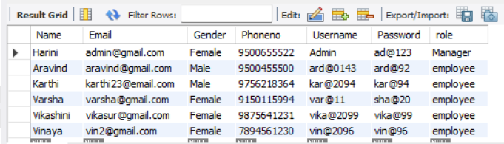

FIG 5.1

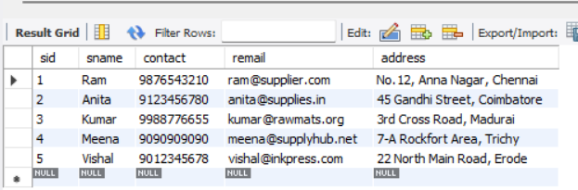

FIG 5.2

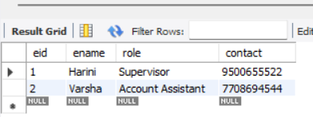

FIG 5.3

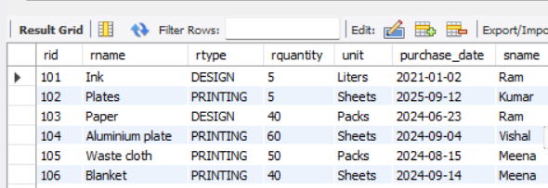
FIG 5.4

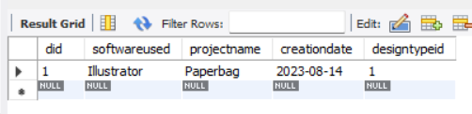

FIG 5.5

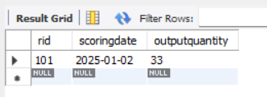
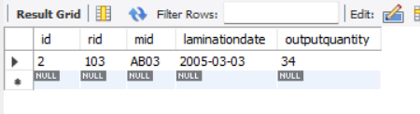
FIG 5.7

FIG 5.6

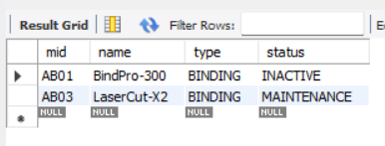
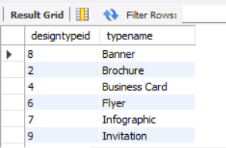

FIG 5.8

FIG 5.9

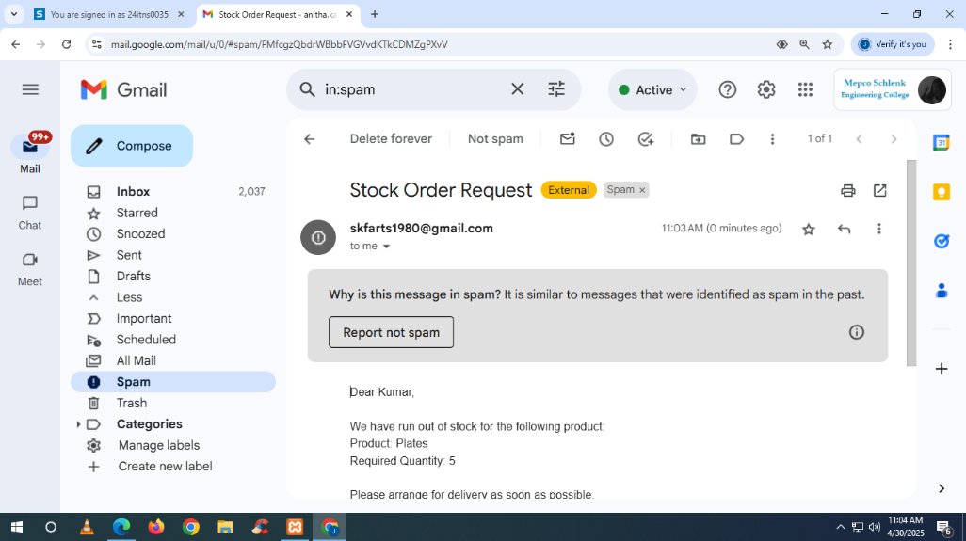

FIG 5.10

5.1. SCREEN SHOTS
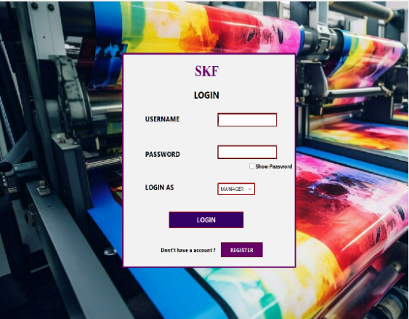
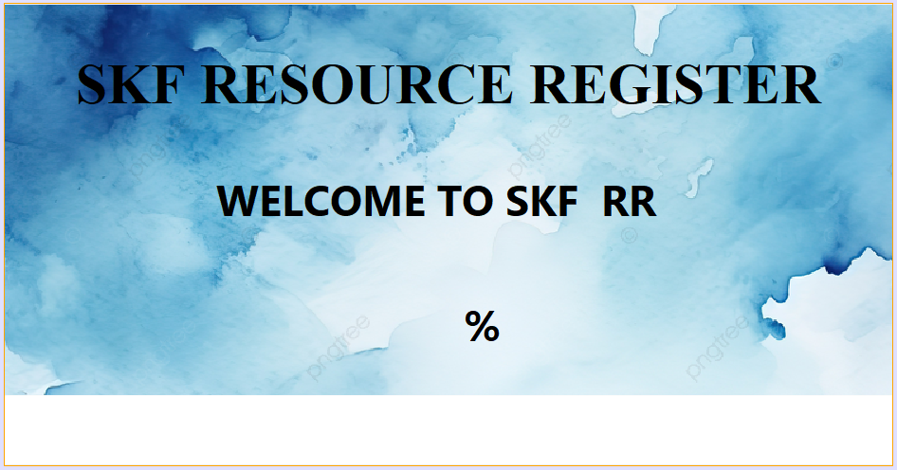
FIG 5.1.2
FIG 5.1.1
FIG 5.1.2
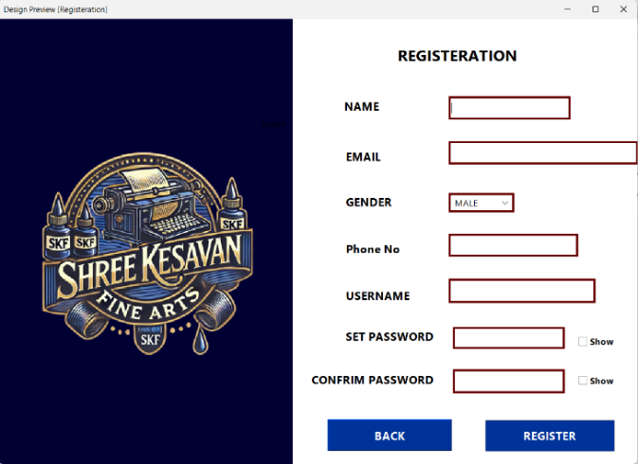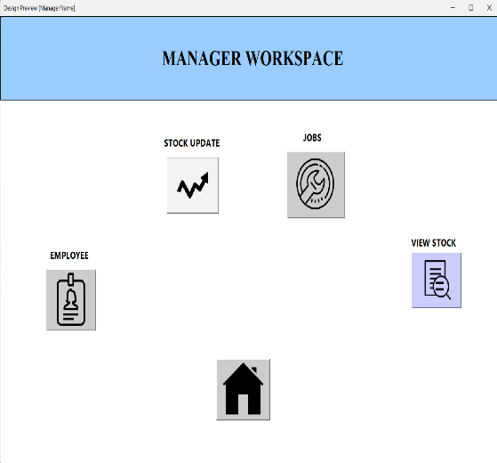
FIG 5.1.4
FIG 5.1.3

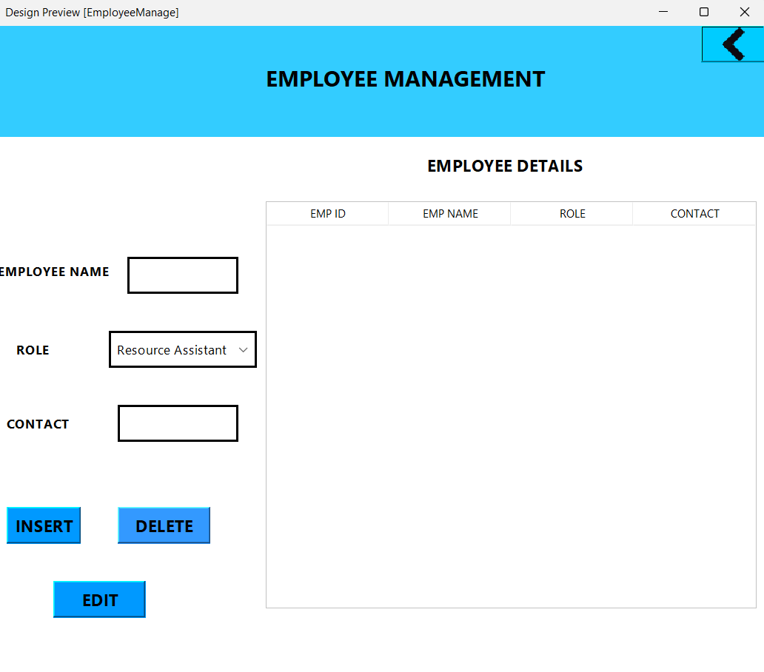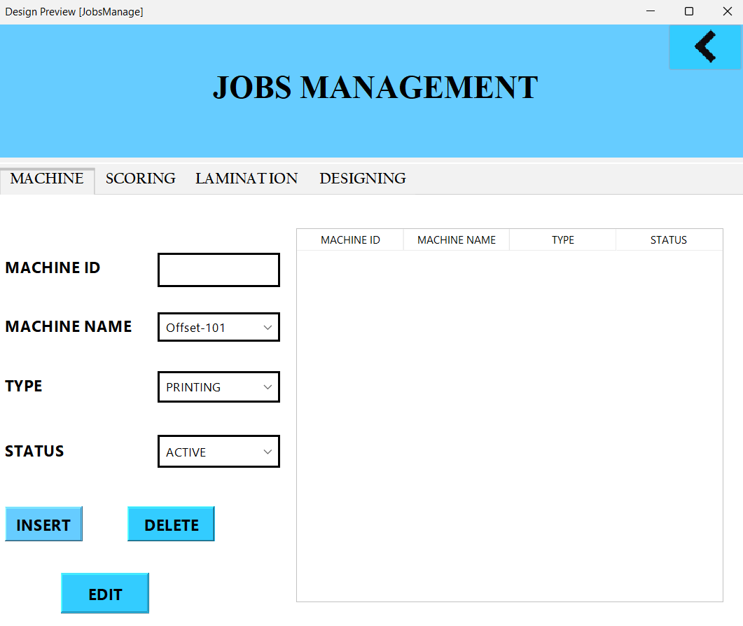
FIG 5.1.6
FIG 5.1.5

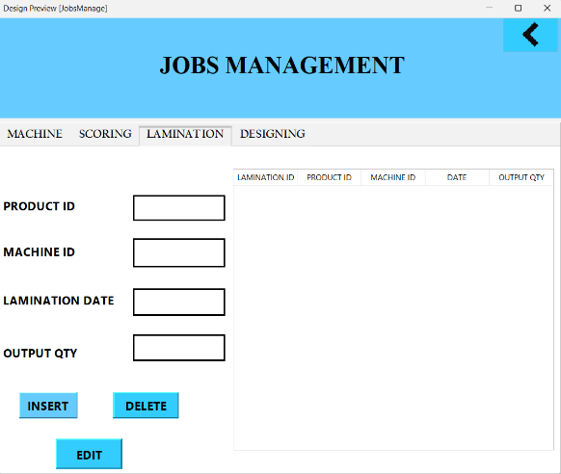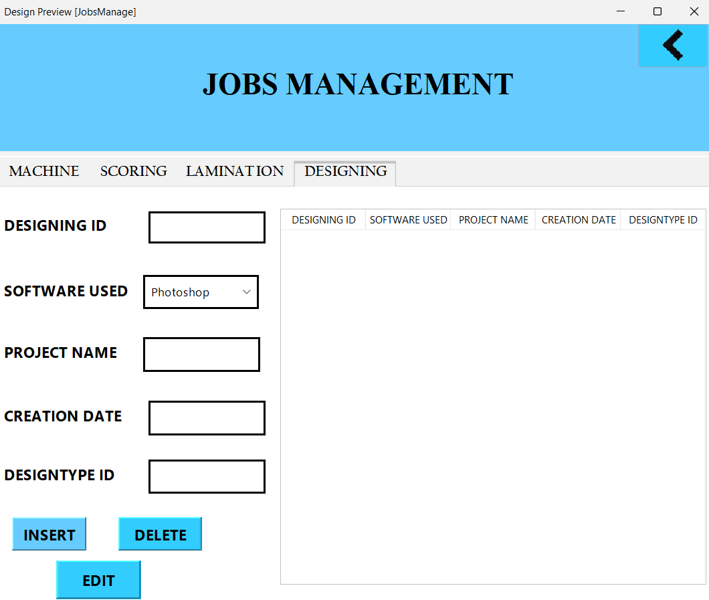
FIG 5.1.8
FIG 5.1.7

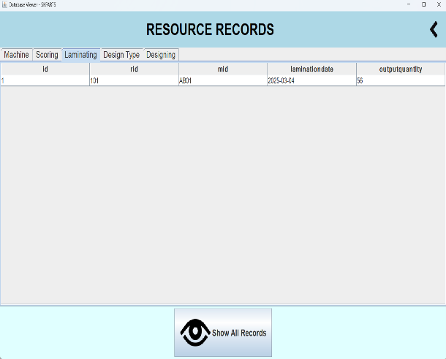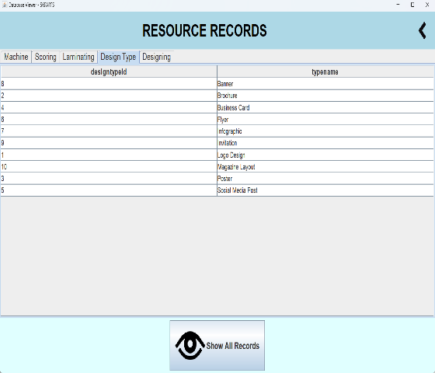
FIG 5.1.10
FIG 5.1.9

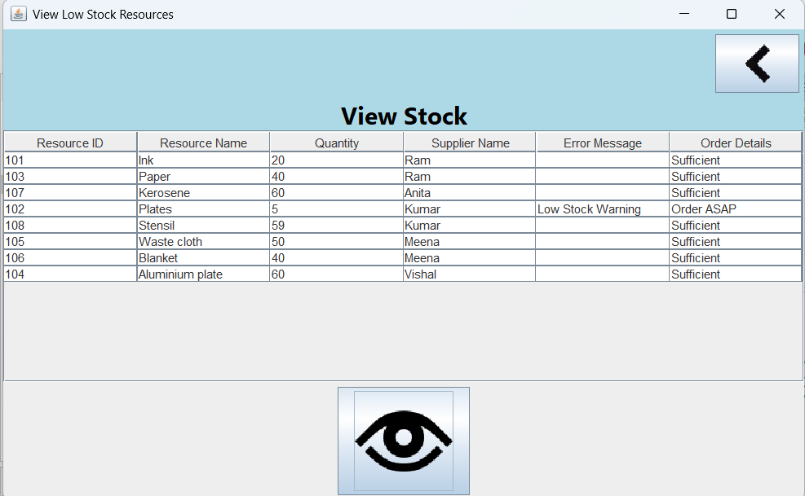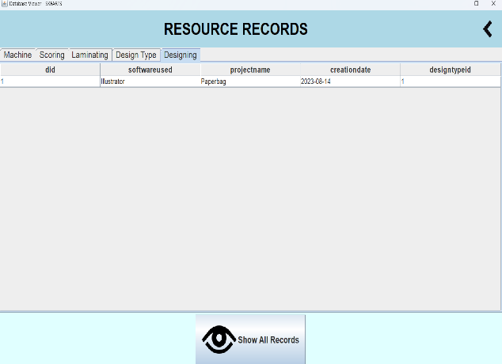
FIG 5.1.12 6.2.12
FIG 5.1.11

CHAPTER 6
CONCLUSION

- The Java Swing application developed for the printing press industry effectively addresses the challenges outlined in the problem statement. By providing a comprehensive solution for resource management, the application enhances operational efficiency, improves data accuracy, and supports the organization's growth.

- The various classes and methods work together to create a seamless user experience, allowing employees and managers to manage resources, track stock, and make informed decisions. The integration of a robust database structure and user-friendly interface ensures that the application meets the needs of the organization while providing a solid foundation for future enhancements.

- In summary, this application not only solves the immediate problems faced by the printing press industry but also lays the groundwork for ongoing improvements in resource management and operational efficiency. By leveraging technology effectively, the organization can better serve its customers and adapt to the ever-changing demands of the market.

CHAPTER 7
REFERENCES

Websites:
1.https://www.javatpoint.com/jdbc-mysql-database-connection-in-java
2. https://netbeans.apache.org/kb/index.html
3. https://dev.mysql.com/doc/connector-j/en/
4. https://www.javatpoint.com/example-of-jdbc-with-oracle-database

Books:
  - Java: The Complete Reference (11th Edition) – Herbert Schildt
  - Beginning Java Programming: The Object-Oriented Approach – Bart Baesens et al.
  - Java Programming for Beginners – Mark Lassoff
  - Database System Concepts by Silberschatz, Korth, and Sudarshan
  - An Introduction to Database Systems by C.J. Date

PDF And Short Notes:
- An Introduction to GUI Programming with Java Swing
- Oracle JDBC Developer’s Guide
- Introduction to Programming Using Java (Swing Edition)
- SQL Tutorial – TutorialsPoint
- TutorialsPoint – DBMS Quick Guide

7.1. APPENDIX
